Southampton Solent University

SCHOOL OF MEDIA, ARTS AND TECHNOLOGY

**BSc (Hons) Computer Games (Software Development)**

**2019**

**Flavio Fiori**

**“Procedural Terrain Generation”**

***“The title of your dissertation”***

Supervisor : Philip Alassad

Date of submission : Working on Progress

Contents

1. Progress Report 4

1.1 Overview 4

1.1.1 Project 4

1.1.2 Why I want to undertake this project and how it is going to challenge me 4

2.1.3 Aims 6

2.1.4 Objectives 6

2.1.5 Stretch Goals 7

2.2 Project Specification 7

2.2.1 Software 7

2.3 Research 8

2.3.1 Perlin Noise 8

2.3.2 Diamond-Square Algorithm 12

2.3.3 Simplex Noise 16

2.3.4 Thermal erosion 16

2.4 Prototyping 17

2.5 Project Management 18

2.5.1 Methodologies 18

2.5.2 Tools for Time Management 21

2.6 Design 23

2.6.1 High Level Flow Chart 24

2.6.2 Perlin Noise Class 25

2.6.3 Mesh Generation Class 25

2.6.4 Map Generation Class 26

2.7 Project Plan 27

2.7.1 Time estimation 27

2.7.2 Feasibility and Risk 30

2.7.3 Risk Analysis 31

3. Final Report 32

3.4 Sprint 4 – Implementing the Mesh Generator class to display the heightmap 27/02/2019 – 08/03/2019 32

3.5 Sprint 5 – Graphic interface to change the terrain generation on the go and Level of detail implementation 09/03/2019 – 18/03/2019 36

3.6 Sprint 6 – Studying fractals and fractal implementation for future using in hydraulic erosion 22/03/2019 – 05/04/2019 42

3.7 Sprint 7 – Hydraulic erosion 06/04/2019 – 01/05/2019 53

References 54

Bibliography 56

Appendix 59

Appendix A) Reading List 59

Appendix B) Literature review 60

B.1) Terrain Synthesis Techniques Research 60

B.2) Perlin Noise Research 61

B.3) Diamond-Square Research 63

Appendix C) Images 64

C.1) Prototype using the 2D Perlin noise function that I created 64

C.2) Prototype using the Unity Perlin Noise Function 64

C.3) Perlin Noise from my function 65

C.4) Perlin Noise from unity 66

C.5) Ken Perlin’s original gradient function 66

C.6) Riven Calculate Perlin Noise twice as fast 67

C.7) Noise Displaced super quadric with old interpolants 67

C.8) Noise Displaced super quadric with new interpolants 68

C.9) Risk and Analysis 69

C.10) Gantt Chart 70

# Progress Report

## Overview

### Project

The goal is to create a procedural generation of terrain, where the user can define the size of it. Randomly generate a smooth transition from mountains to valleys, simulating a terrain and applying textures in relation of the type of terrain. The end goal is to be able to create a plug-in for Unity that allows random terrain generation inside the editor, without the need for the user to design and generate terrain.

### Why I want to undertake this project and how it is going to challenge me

I have chosen this project for two reasons: personal interest in terrain generation and to increase my employabilityskills, as technical programmers that can develop modular tools are highly requested in the games industry and are a great asset to any team. I aim to increase my C# skills as also to overcome any challenge that comes with programming randomly generated terrains such as the algorithms that are involved or Hight maps. The final product should be of industry standard and I would like to design it in a user friendly manner so that it could be launched in the Unity Asset store. In order to achieve the goal, I will also have to apply and improve my time management skills.

### 2.1.3 Aims

The aim of this project is to create a procedural terrain generation.

This project will contain different researches into what are the most cost-efficient terrain synthesis techniques to use for procedural terrain generation.

When the terrain generation is successfully complete, a method for synthesis of eroded terrain is going to be implemented (Olsen, 2004).

### 2.1.4 Objectives

* Research the best algorithms to create procedural terrain.
* Implement one of the three algorithms to create procedural generated terrain:
* Perlin Noise
* Diamond-Square
* Simplex Noise
* Create a 3D wireframe in unity using the algorithm selected
* Implement an algorithm for eroded terrain
  + Thermal erosion
* Implement the Diamond-Square algorithm to create the noise and generate the height maps using this algorithm.
* Implement the Simplex Noise algorithm to create the noise and generate the height maps using the algorithm.
* In unity editor the user can chose what algorithm use when generating the terrain.

### 2.1.5 Stretch Goals

* Create the procedural terrain generation plug-in for unity
* Implement the terrain synthesis techniques in C++ and OpenGL
* Create the Graphic class
* Create the Mesh Class
* Generate a 3D terrain using the terrain synthesis technique

## 2.2 Project Specification

### 2.2.1 Software

The required software needed is Visual Studio, Unity, Microsoft Excel, Microsoft Word, GitHub, Gantt Project, Visio, Photoshop, Kanbanflow, HacknPlan, and Google Drive.

* Visual studio is my favourite IDE for creating the scripts in C#.
* Unity is the 3D engine that will be responsible to handle and render the procedural terrain.
* Microsoft Excel is the program that will be responsible to create the work schedule for each week
* Microsoft Word allows me to create the documentation for the project.
* Github and Google Drive is where the backups of the project are stored.
* Gantt Project is the responsible program to create the Gantt chart for this project.
* Visio is where I am going to create the UML Class Diagrams for the project.
* Photoshop is used for the making of the terrain textures.

## Research

### 2.3.1 Perlin Noise

#### 2.3.1.1 What it is

Perlin Noise is a type of gradient noise created by Ken Perlin in 1983. Noise can be used to create a wide variety of natural looking textures. When combining noise into mathematical expressions it is possible to achieve procedural textures. The benefits of procedural textures is that they do not need a source texture image. They can be applied directly to 3D objects without the need to create the texture mapping responsible to wrap the texture around the object.

#### 2.3.1.2 How it works

1. In the noise method parameter, an initial value is given

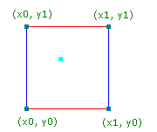

Figure - Initial values the 4 grid points

1. The original algorithm created the pseudo-random gradient the following way: $R^{n} to R$. Currently the most common uses are for n=1 (animations), n=2 (cheap texture hacks), n=3 (less-cheap texture hacks) (Perlin 2001).
2. For each coordinate:
   1. Generates a pseudo-random gradient vector
   2. This gradient vector defines a positive direction and a negative one.

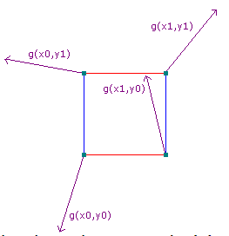

Figure - Pseudorandom gradient

1. Linearly combine a weighted sum, using the function to ease the curve in each dimension ${3t}^{2}-{2t}^{3}$. This function is applied to the U and V values. This make changes more gradual as one approaches integral coordinates.

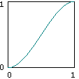

Figure - Ease Curve

##### 2.3.1.2.1 The 4 neighbours in two dimensions

In two dimensions, there are 4 surrounding grid points. For each grid point, a vector going from the grid point to (x,y) is generated, this is easily obtained by subtracting the grid point from (x,y).

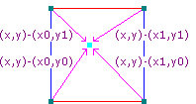

Figure - The 4 neighbours

#### 2.3.1.3 Changes in the Perlin Noise Algorithm

During the research it was discovered that the original Perlin Noise created in 1983 had two deficiencies in the algorithm. One of them was the gradient computation, to fix this problem Ken Perlin discovered that was not necessary the G equation to be random at all. In the journal Improving Noise the G function was replaced by 12 vectors defined by the directions from the centre of a cube to its edges instead of the original G equation that take each grid point and assigns a pseudorandom vector of length 1 in R^2 (Perlin, 2002). The other deficiency was found in the function to ease the curve, see (Appendix C.7) (Appendix C.8)

“The above algorithm is very efficient but contains some deficiencies. One is in the cubic interpolant function's second derivative 6-12t, which is not zero at either t=0 or t=1. This nonzero value creates second order discontinuities across the coordinate-aligned faces of adjoining cubic cells.” (Perlin, 2002)

### 2.3.2 Diamond-Square Algorithm

#### 2.3.2.1 What it is?

Diamond-Square algorithm is a method to create a fractal landscape. A fractal landscape is a simulation of a natural terrain appearance. This algorithm was introduced by Alain Fournier, Don Fussel and Loren Carpenter at the annual conference on computer graphics named SIGGRAPH (Fournier, Fussell and Carpenter, 1982).

#### 2.3.2.2 How it works?

Diamond-Square algorithm works basically this way, first you need to create a 2D vertex field, where it is expressed in the following form: $2^{n}+1$. This makes sure that for every set of vertices on the corner, there will always be a vertex on the centre (Olse, 2004).

The algorithm is made by three steps:

1. Initialize Values
2. Perform the diamond step
3. Perform the Square step

##### 2.3.2.2.1 Initialize Values

The algorithm starts to initialize the array values for the initial four corner points within a specific range set by the user.

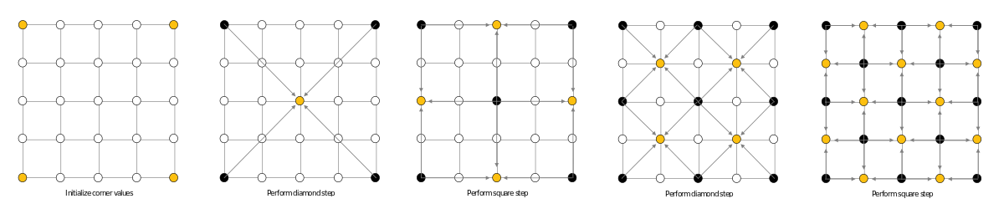

Figure - Diamond-Square Initializing the corner values

##### 2.3.2.2.2 Diamond Step

The diamond step, consists of going through each square in the array, set a centre of that square to be the result of the average of the four corner points plus a random value.



Figure - Diamond-Square performing the diamond step

##### 2.3.2.2.3 Square Step

In the square step for each diamond in the array, sets the midpoint of that diamond to be the average of the four corners plus a random value. For each iteration the random value is reduced, until there are no more vertices.

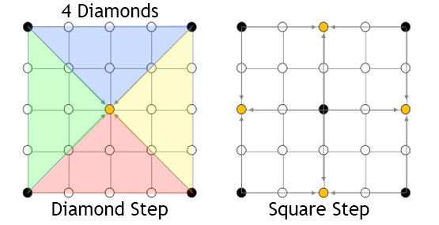

Figure - Diamond-Square performing the square step



Figure - Diamond-Square iteration

### 2.3.3 Simplex Noise

Simplex Noise is an algorithm created in 2001 by Ken Perlin to address the limitation of the Perlin Noise algorithm.

#### 2.3.3.1 Advantages compared to Perlin Noise

* Lower computational complexity, requiring a small number of multiplications, making it cheaper to compute than the Perlin Noise.
* Is visually isotropic, this means that the magnitude has the same value when measured in different directions.
* There are no more grid artefacts.
* Easier to implement in hardware.

### 2.3.4 Thermal erosion

Thermal Erosion is a process that simulates the breaking down of material, this breaking down then is moved by the wind or water to the bottom (Olse, 2004; Rohde, 2013).

#### 2.3.4.1 How it works

An amount of the material that is at the top of a slope whose inclination is above a threshold value, will be moved down in the slope.

## 2.4 Prototyping

When developing a prototype of the procedural terrain, the premade Unity Perlin Noise function was used to generate a noise map and after converting it to a colour map (Appendix C.2), this allowed to get an idea of the result of the prototype.

With the prototype in hand, I proceeded to implement the Perlin Noise function. This function was based on the java reference implementation of improved noise function with slight modifications.

When creating the noise function, few problems raised, one of them is the original Ken Perlin’s gradient function using complicated, and confusing bit-flipping code to calculate the dot product of a randomly selected vector and the 8 location vectors (Appendix C.5) (Perlin 2002).

An easy alternate way of writing the code and even fast to compile in many languages, is to write a switch statement with all the 16 possible cases from the 8 location vectors (Appendix C.6) (Riven 2010).

Is possible to see the first result of the 2D Perlin noise function that was implemented in the (Appendix C.1). While this function was far from perfect due to the fact that sometimes the output was negative, the result was satisfactory. To improve the function it was necessary to add the third axis (Z), to create a the correct output value (Appendix C.3) similar to the original Unity function (Appendix C.4).

## 2.5 Project Management

### 2.5.1 Methodologies

#### 2.5.1.1 Waterfall

In the waterfall methodology the scope of the project is defined in the beginning and cannot be changed once development starts.

The advantages of using waterfall methodology is the fact that it is going to help organize the project with defined tasks. In the future, if all the steps are followed, a complete product is achieved. The waterfall model is simple and easy to understand, each phase of the model has specific deliverable dates and review processes, helping to create a linear structure for the project (ISTQB 2013).

##### 2.5.1.1.1 Pros

* Simple to Implement
* Easier to manage due to the fact that the stages are more rigid
* Is great for small projects

2.5.1.1.2 Cons

* Difficult to make changes once the project begins
* Software is created near the end of the development cycle
* The risks are high and unpredictable
* Does not work well for long projects

#### 2.5.1.2 Agile

Agile use sprints, each sprint is a time period that is allocated for each phase of the project. A sprint is complete when the time defined for it expires. If the development of the project is not satisfactory in that sprint, or the tasks were not met, then that sprint is considered a fail, sending all the failed tasks to the next sprint and so on.

##### 2.5.1.2.1 Pros

* Software is created in the beginning of the development cycle
* Decreases the risk associated with software development
* Requirements can change during the development of the project, implementing new features, this helps companies create the right product for the market

##### 2.5.1.2.2 Cons

* It is more focused on the developer instead of the client
* Easy to get lost if no clear focus is applied in the final outcome
* Less focus on the product design
* Ineffective in large organizations

#### 2.5.1.3 Time-Box

Time-box is a short period of time that person works towards a specific goal. If this goal is not reached when the time period ends, then the person stops working on the project and start evaluating what went well, what went wrong, has the goal been met, or to some extent met (Rothman 2017).

##### 2.5.1.3.1 Pros

* Easy to implement
* Easy to follow
* Always updated with the project progress
* Focus on the important things under time constraints

##### 2.5.1.3.2 Cons

* Time consuming
* Sometimes work cannot be completed on time, causing unfinished products.
* Time estimation is not accurate

### 2.5.2 Tools for Time Management

#### 2.5.2.1 Trello

Trello is a project management application that uses the Kanban system. The projects are represented by boards, each of the boards contains a list of tasks. The tasks are represented by cards, that are created inside the boards.

“Trello is an online tool for managing projects and personal tasks. That may sound rather prosaic. But this increasingly popular app often inspires the sort of passion usually reserved for consumer apps like Pinterest or Instagram. It’s the kind of business software that slips into businesses through the backdoor, just because individual employees like how it works.” (Finley 2014)

#### 2.5.2.2 KanBanFlow

KanBan Flow is a cloud-based project management solution similar to trello, it uses the Kanban system but there is one thing that it excels compared to trello. KanbanFlow features the pomodoro technique for time tracking of tasks. This feature makes KanbanFlow my number one choice in time management tools (Software Advice 2017).

#### 2.5.2.3 HacknPlan

Basically, HacknPlan is an alternative of trello for game developers. The difference is that HacknPlan brings game design and task management together to provide a better organization while creating a game project. HacknPlan features stock headings with categories like programming, art, design, writing and more. Not only that but also each heading features different subcategories; In programming there is AI, Physics and more (Estevez 2019; GameDesigning 2018).

#### 2.5.2.4 Microsoft OneNote

Microsoft OneNote is an app that simulates a notebook, were the user can gather handwritten or typed notes, drawings or even audio commentaries.

## 2.6 Design

### 2.6.1 High Level Flow Chart

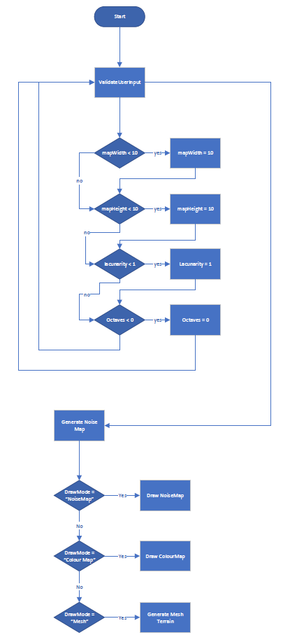

### 2.6.2 Perlin Noise Class

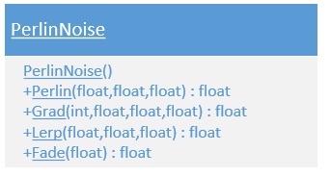

### 2.6.3 Mesh Generation Class

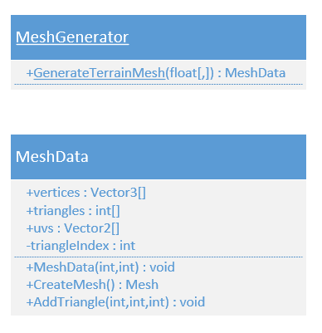

### 2.6.4 Map Generation Class

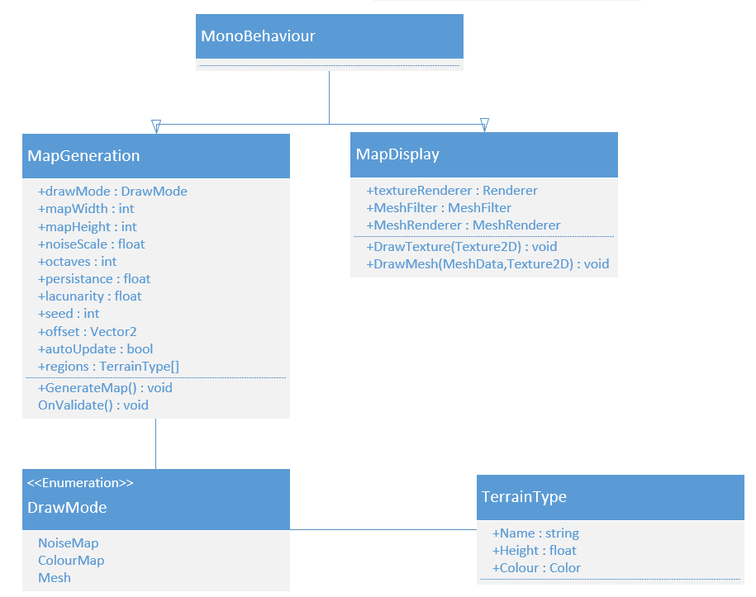

## 2.7 Project Plan

Planning a project beforehand is a critical process to ensure that the project is going to be completed successfully. To ensure that everything goes as planned, a methodology named “Time-Box” is going to be applied to the project.

At the start of each week, a Gant Chart and a work break down structure is going to be created, this will be called a sprint. The risks will be managed at the end of each sprint.

### 2.7.1 Time estimation

To see the full Gantt Chart, see Appendix C.10_Gantt_Chart)

#### 2.7.1.1 Sprint 1 – Initial Setup

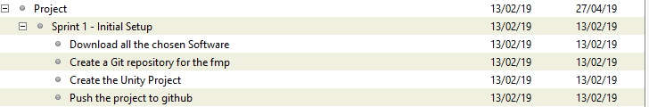

Figure - Gantt Chart Sprint 1

#### 2.7.1.2 Sprint 2 – Algorithm Researching

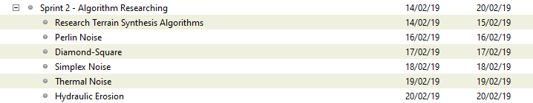

Figure - Gantt Chart Sprint 2

#### 2.7.1.3 Sprint 3 – Finishing the Perlin Noise Function and Research in Terrain Synthesis techniques

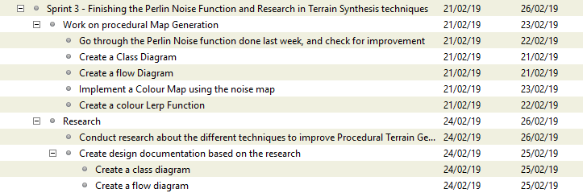

Figure 11 – Gantt Chart Sprint 3

Week 13/02/2019 – 23/02/2019

WBS

1. Work on the Procedural Map Generation (50%) (15 hours)
   1. Create a Class Diagram (5% Design)1h30m
   2. Create a flow Diagram (5% Design)1h30m
   3. Go through the Perlin Noise function done last week, and check for improvement (10% Programming)3h
   4. Implement a Colour Map using the noise map (20% Research/Programming)6h
   5. Create a colour Lerp Function (10% Research/Programming)3h
2. Research (50%) (15 hours)
   1. Conduct research about the different techniques to improve Procedural Terrain Generation (20% Research)
   2. Conduct research on the Diamond-square algorithm (20% Research)
   3. Create design documentation based on the research (10% Design)
      1. Create a class diagram (5% Design)
      2. Create a flow diagram (5% Design)

#### 2.7.1.4 Sprint 4 – Implementing the Mesh Generator class to display the heightmap



Figure - Gantt Chart Sprint 4

#### 2.7.1.5 Sprint 5 – Graphic interface to change the terrain generation on the go



Figure - Gantt Chart Sprint 5

#### 2.7.1.6 Sprint 6 – Implement Thermal Noise algorithm for terrain erosion



Figure - Gantt Chart Sprint 6

#### 2.7.1.7 Sprint 7 – Implement Hydraulic Erosion algorithm



Figure - Gantt Chart Sprint 7

#### 2.7.1.8 Sprint 8 – Create a Unity Plug-in and Work on the final report



Figure - Gantt Chart Sprint 8

### 2.7.2 Feasibility and Risk

To prevent any risk from occurring, I am going to use time management techniques like pomodoro and Kanban (Cirillo 2006; Cummings 2018; Cirillo 2017; Marcus Hammarberg and Joakim Sundén 2014; Anderson 2010; Peterson 2015).

I believe that creating a terrain generator with Hight maps is a feasible project, for avoiding some of the risks, I will make sure that I work at least 30 hours per week on the project. To see the risks that may occur during the development of this project see the Risk Analysis (Appendix C.9).

### 2.7.3 Risk Analysis

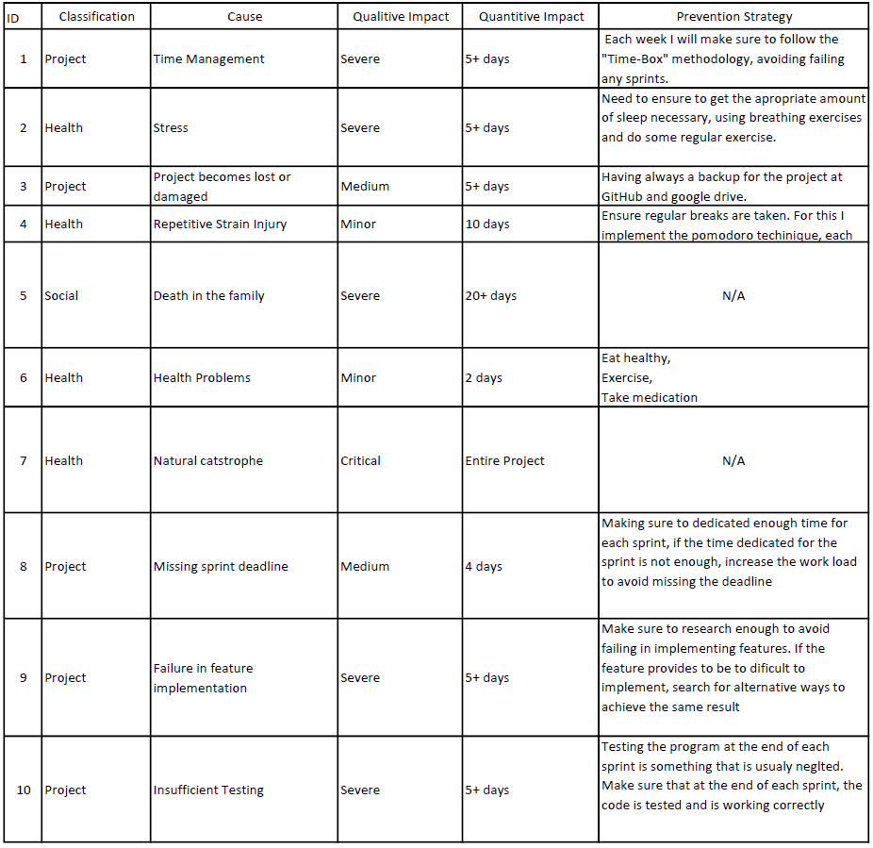

# Final Report

## Sprint 1 – Initial Setup 13/02/2019 – 13/02/2019

### Abstract

The purpose of this sprint is to download the required software for the development of the Procedural Terrain Generation. The project is going to be backed up in GitHub. Git is a version control and source code management. At the end of this sprint the project should be ready for development.

### Research

During this sprint the author searched for everything that needed for creating this project.

The necessary programs that are going to be used for the development of the procedural terrain generation are the following:

#### Unity Engine

Update for the latest possible version of Unity before starting the project (Ver. 2018.3.3f1). The Unity engine is responsible for rendering the 3D graphics of the terrain.

#### Visual Studio

Preferred IDE by the author for programming.

#### Gantt Project

The program responsible to create the Gantt chart

At the end when everything was downloaded, the author created a Unity project, script folder and a sprint folder, where each sprint is going to have an individual word document. When all of this was created the author pushed all the documents to Git.

### Sprint Review

The sprint was a success, nothing was challenging on this sprint, it involved only on the creation of a project and pushing the content to a git repository.

### WBS

1. Download all the chosen Software (70%) (3.5 hours)
2. Create a Git repository for the final major project (8%) (0.4 hours)
3. Create the Unity Project (6%) (0.3 hours)
4. Create the necessary project folders (8%) (0.4 hours)
5. Push the project to git (8%) (0.4 hours)

## Sprint 2 – Algorithm Researching 14/02/2019 – 20/02/2019

### Abstract

The main goal of this sprint is researching the best algorithms for procedural terrain generation. Not only this sprint is going to be one of the most important ones but also it will dictate the outcome of the project.

### Research

After researching for a while, the author created a list with the following terrain synthesis algorithms:

#### Perlin Noise

Perlin noise is an algorithm developed by Ken Perlin in 1983. This algorithm is used to create a type of noise that creates natural looking textures [2.3.1 Perlin Noise].

#### Diamond-Square

Diamond-Square is a well know algorithm for procedural terrain generation. It is created by Alain Fournier, Don Fussel and Loren Carpenter. Practically is called inside a recursive function until there are no more vertices to recurse from.

For more information in how this algorithm works check the section in the progress report [2.3.2 Diamond-Square Algorithm].

#### Simplex Noise

Simple Noise is a new version from Perlin Noise made by Ken Perlin in 2001, this version was created to overcome some limitation of the Perlin Noise [2.3.3].

#### Thermal Noise

Thermal Noise is an algorithm responsible for terrain erosion through the breaking down of rocks, soil and minerals and they are moved by the wind to the bottom [2.3.4 Thermal Erosion].

#### Hydraulic Erosion

Hydraulic Erosion is a process that creates erosion through the water flow, practically there is composed by two things, one of them is the sediment capacity that the water can carry and another one is the deposit process. The water starts eroding the surfaces it touches and carries that surface as sediment, when the sediment capacity of the water reaches to its maximum amount it starts to deposit that sediment.

### Sprint Review

This sprint was a success, at the end it is possible to conclude that the author learned the most used algorithms for terrain generation and the two most common used algorithms for terrain erosion. The author then decided to choose the Perlin Noise algorithm for the noise map generation and hydraulic erosion for implementing the terrain erosion.

### WBS

1. Research Terrain Synthesis Algorithms (30%) (9 hours)
2. Perlin Noise (14%) (4.2 hours)
3. Diamond-Square (14%) (4.2 hours)
4. Simplex Noise (14%) (4.2 hours)
5. Thermal Noise (14%) (4.2 hours)
6. Hydraulic Erosion (14%) (4.2 hours)

## Sprint 3 – Finishing the Perlin Noise method and research in terrain synthesis techniques 21/02/19 – 26/02/19

### Abstract

The goal of this sprint is to finish the Perlin Noise class implementation, research ways to improve the terrain synthesis techniques, implementing some program design like the UML class diagram that describes the structure of the class.

### Research

During the research for improving the Perlin Noise algorithm a journal named Improving Noise by Ken Perlin (Perlin, 2002) explained two deficiencies present on the algorithm; one of those was the fade method, this method is responsible for easing the curve and the other one was the gradient calculation.

#### Fade function

The first thing was improving the fade function by changing the formula, so the author replaced the method present in [Figure 1] to the new method present in [Figure 2].

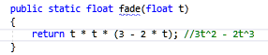

Figure - Original Fade Function

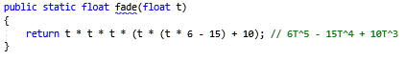

Figure - Fade function improved

Just by simple changing the fade function it is possible to perceive the increased level of detail on the right image, the sand is creating a better pattern and it is possible to perceive that now the water is present in places that before was just sand. This is due to the fact that now the values get even closer to integral coordinates, in other words closer to 1 and 0 [Figure 3].

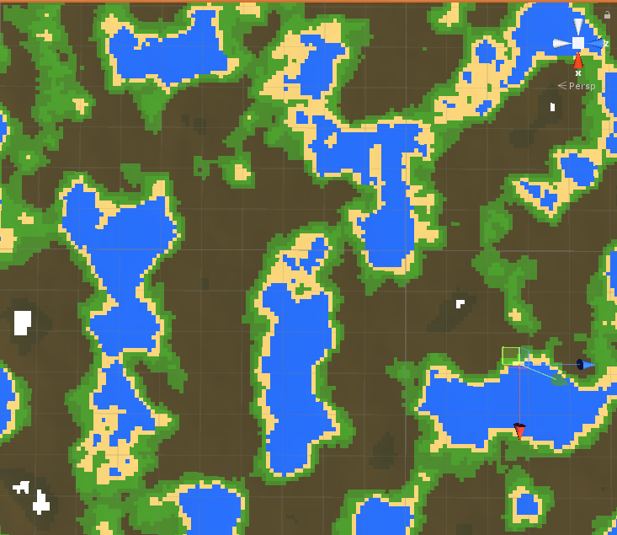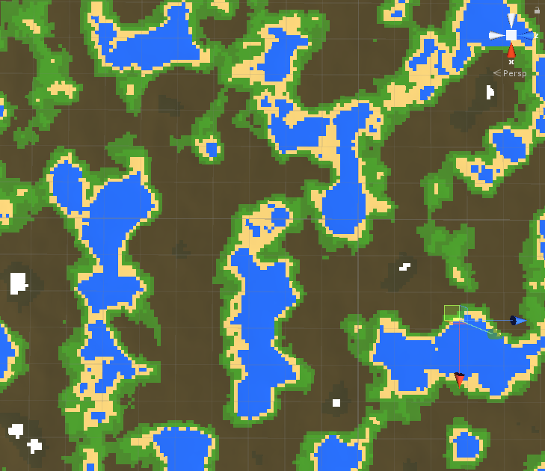

Figure - Original Fade Function left, Improved fade function on the right.

#### Gradient Function

This function is used to calculate the dot product of a randomly selected gradient vector in 8 different locations. The original function [Figure 4] made by Ken Perlin’s uses complicated and confusing bit-flipping code to calculate the dot product and due to that fact, the author was not satisfied, he then decided to begin a research for an easy and more understandable solution.

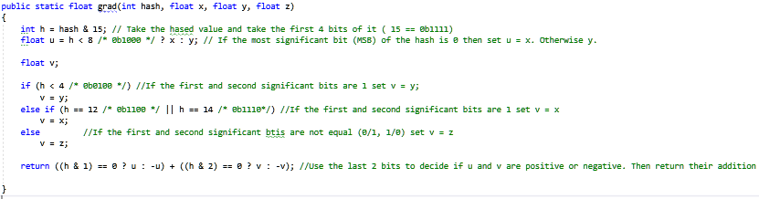

Figure - Gradient Original Function

After a few hours of researching the author found a great solution that seems to have the same effect from the original one (Riven 2010); not only is easier to understand but is twice as fast from the original due to the fact that uses a switch statement and gets all the 16 possible outcomes from the gradient in a simple way instead of using bit manipulation [Figure 5].

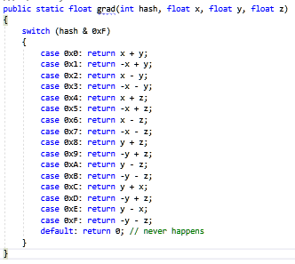

Figure - Simple Gradient Function

To prove that the function gets the same result, in the [Figure 6] is possible to see the two different functions side by side, and that the result is totally identical.

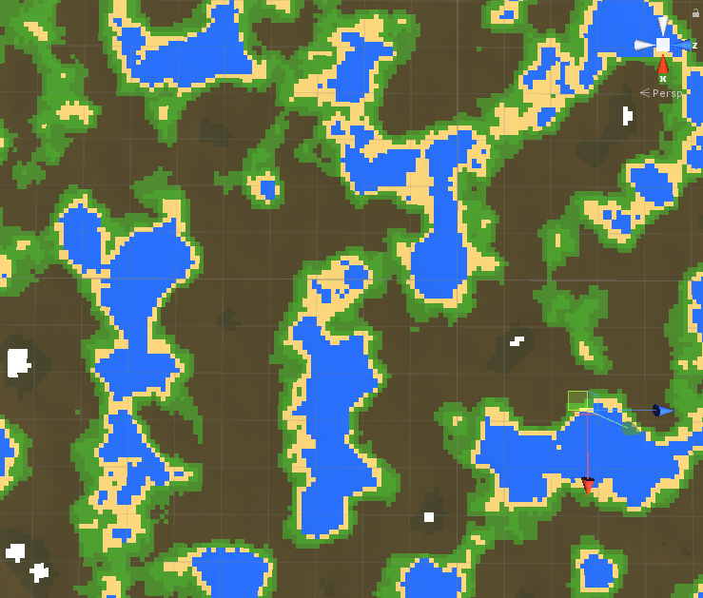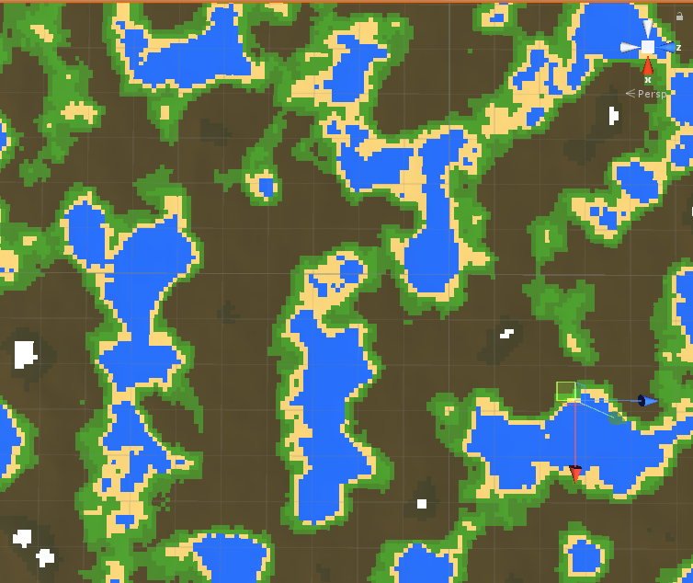

Figure - Original Gradient function | Simple Gradient Function

#### Colour Map

##### Overview

For creating the colour map the author needed to find a way to pass some values using the user interface in unity. So, the first thing was to create a public struct with the three essential attributes; the name, noise height and the colour [Figure 7].

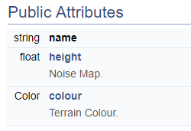

Figure - Struct Attributes

Each of the terrains now can be defined in the unity interface, where the water colour is given for every part of the noise map that has the value between 0.00f - 0.35f while the sand colour is given to the values of between 0.36f - 0.40f. Due to this fact the grass is the last one, the green colour is given the noise values between 0.40 and 0.45f. [Figure 8] [Figure 9].

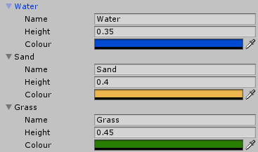

Figure - Unity Array Type of Terrains

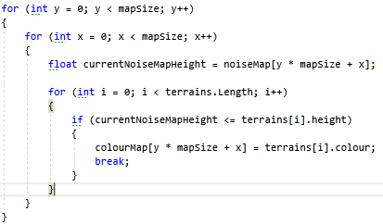

Figure - Adding the colours to the colour map

##### Definition

In [Figure 10] it is possible to see how the ColourMap function is defined.

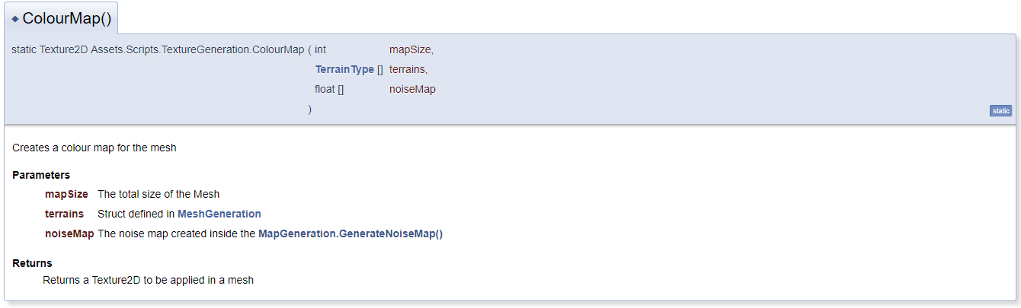

Figure - TextureGeneration.ColourMap()

###### Map Size

The reason why the author passes the mapSize is for creating the total size of the array [Figure 11], and to be able to loop through all the vertices in the map, in this case 65 025 vertices.



Figure – Colour Map array

###### Terrain Type

The TerrainType is essential for knowing how many terrains are defined by the user, going through the array by using the Length variable [Figure 12]. The other use is by getting the height defined by each of the terrains and check if the noise map is smaller or equals to the height, if this is true then apply the selected colour to the colourmap [Figure 13].

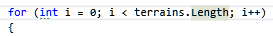

Figure - Terrain Length

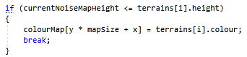

Figure - Noise Map Height

###### Noise Map

The reason why the noiseMap[] is passed in the parameter list is due to the fact that the author needs to know what are the height values for each vertices position. It is possible to retrieve the noise value in that exact vertex’s location creating two for loops less than mapSize and then current noise map value for each iteration [Figure 14].



Figure - Noise Map current value

###### Return

It returns a Texture2D with the size of mapSize in X and mapSize in the Y where the parameter in the function SetPixels() is the colourmap that was created in the code above.

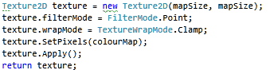

Figure - Return Colour Map

### Sprint Review

The sprint was an overall success, not only the author learned how to improve the noise function and the two deficiencies that were present in the first algorithm made by Ken Perlin, but also learned how to use the noise values and convert them into a Textured2D for later use in any object or mesh.

### WBS

1. Work on procedural Map Generation (50%) (21 hours)
   1. Improve the Perlin Noise method (40%) (8 hours)
   2. Implement a Colour Map using the noise map (60%) (13 hours)
2. Research (50%) (21 hours)
   1. Research about Perlin Noise improvements (90%) (19 hours)
   2. Create a Class Diagram (5%) (1 hours)
   3. Create a Flow Diagram (5%) (1 hours)

## Sprint 4 – Implementing the Mesh Generator class to display the heightmap 27/02/2019 – 08/03/2019

### Abstract

The goal of this sprint is to create a class to generate a basic mesh that can be generated during run time and in the unity editor. When the class is created the goal is to generate the noise map with Perlin Noise and add the values to the Y component of the vertex vector.

### Research / Implementation

I already had previously knowledge in how to create meshes in DirectX, and this uses the same principle.

#### Mesh Class

##### Implementation

The first thing when creating the Mesh Class, the author created a simple sketch and an UML design for the class [Figure 1] [Figure 2].

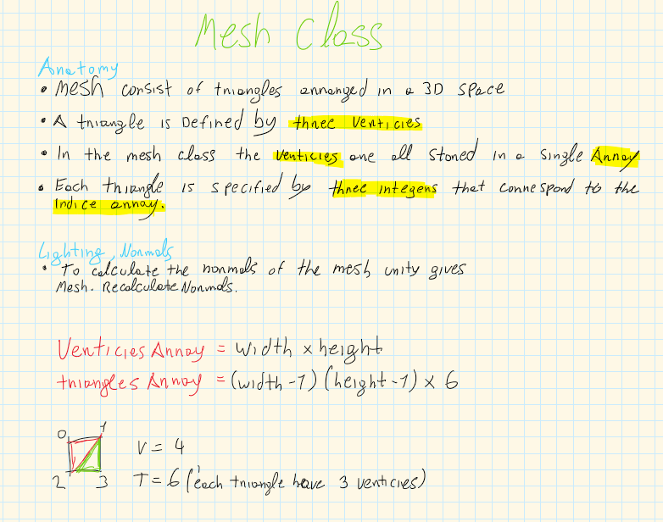

Figure - Mesh Class Sketch

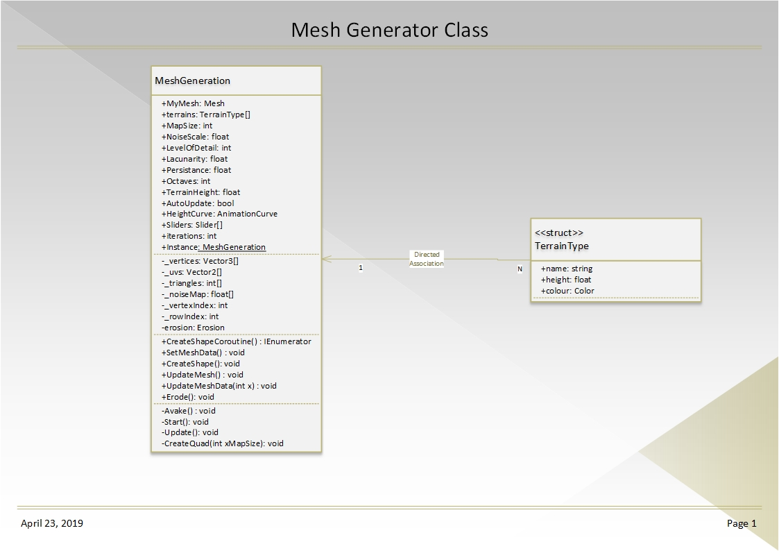

Figure - Mesh Generator Class Design

The second thing to make sure is that the empty game object has attached the following two components: Mesh Filter and Mesh Renderer [Figure 3].

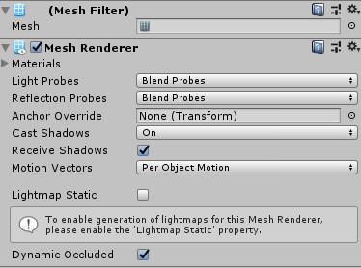

Figure - Requirement of these two components

With the sketch in mind [Figure 1] three initial method were created for the class, SetMeshData(), CreateShape() and UpdateMesh().

###### Set Mesh Data method

This method creates a new mesh, sets the Mesh Filter that is attached to the Empty Game Object to be equals the new mesh and makes sure that the main texture in the Mesh Renderer is set to null. Then it initializes the vertices, triangles and UVs. The initial sketch that the author did to initialize the vertices [Figure 1] was wrong, the fixed result can be seen in [Figure 4], the reason why the improved version has + 1 derives from the fact that the author wanted to have 255 quads when the Map Size was equals to 255.

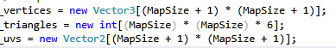

Figure - Vertices, triangles and UVs initialization

###### Create Shape method

This method is responsible for going through each vertex and UV and initialize them with a defined value and passing the height of the noise map to the vertex [Figure 5].

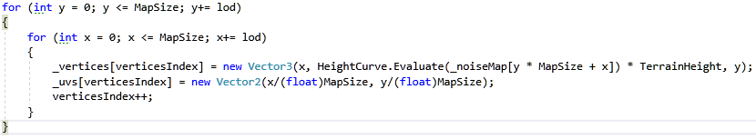

Figure - Vertex and UVs initialization

The other functionality this method is responsible is for creating the triangles for the mesh [Figure 6].

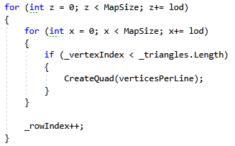

Figure - Triangles generation

###### Animation Curve

To improve the noise map output and create a more realistic terrain the author implemented an animation curve from unity. The animation curve limits the height map range [Figure 8]. In other words, an animation curve in unity has multiple keys [Figure 7] in were the user can control the points in what that curve passes through (Unity Technologies 2018).

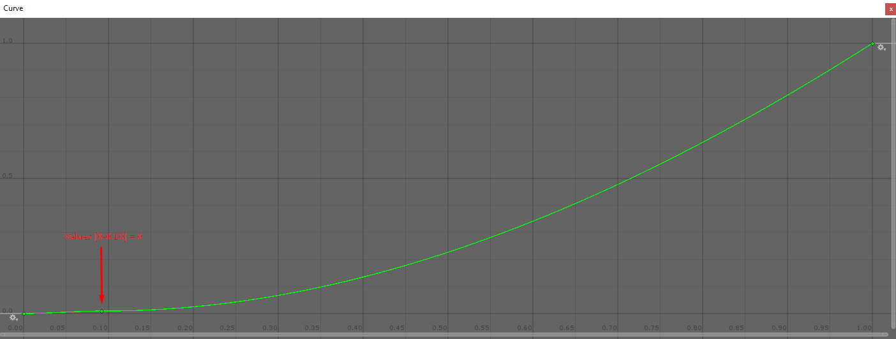

Figure - Animation Curve Graph



Figure - Animation Curve

#### Problems and Solutions

During the implementation of the class the author struggled with different problems. The first problem was found on the initialization of the vertices, for example; The vector3 named vertices had the size of $MapWidth * MapHeight$. Let’s imagine for a moment that the Map Width and Map Height have a value of 10, creating a total size of 100 for the vector. The only problem is that the author wanted to draw 10 quads per row and only 9 were created. The problem was that the last vertex in the rightest corner was present in the other side of the map creating these strange connections [Figure 9].

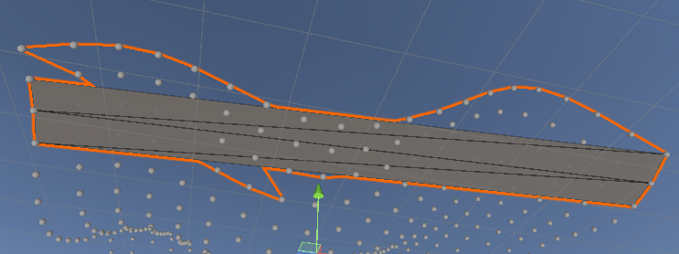

Figure - Generation Mesh Problem

The solution for this was to create the vertices with the size of $(MapWidth + 1)(MapHeight +1)$ [Figure 10]

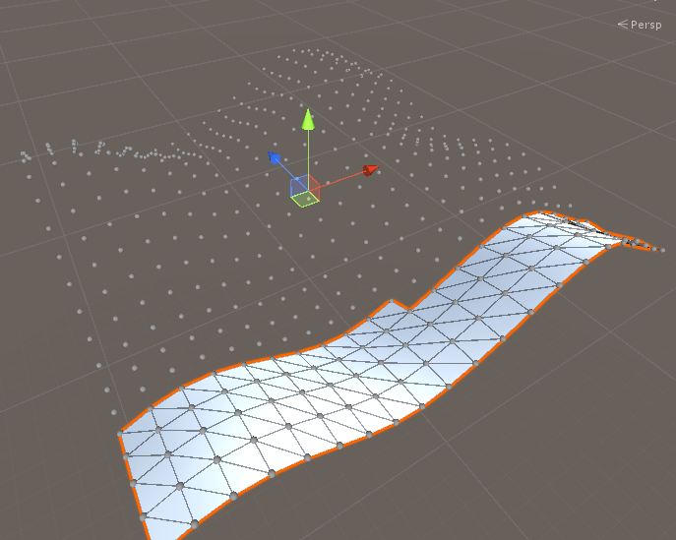

Figure - Mesh Terrain Generation

The second problem was in how the terrain was getting renderer, to fix this problem the author found that limiting the persistence level between 0 and 1 and increasing the lacunarity to 2.6 fixed the problem [Figure 11].

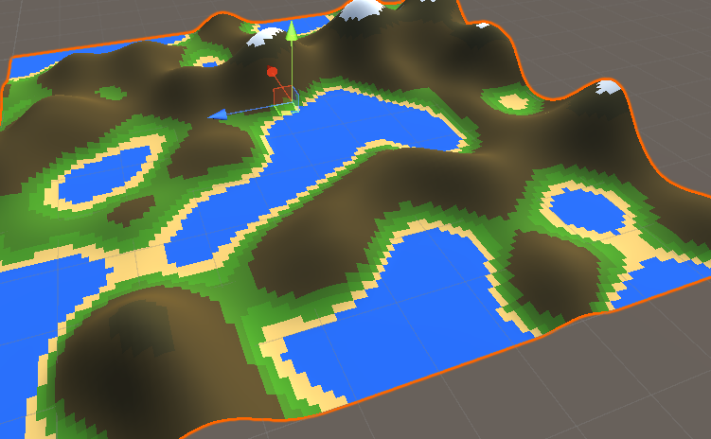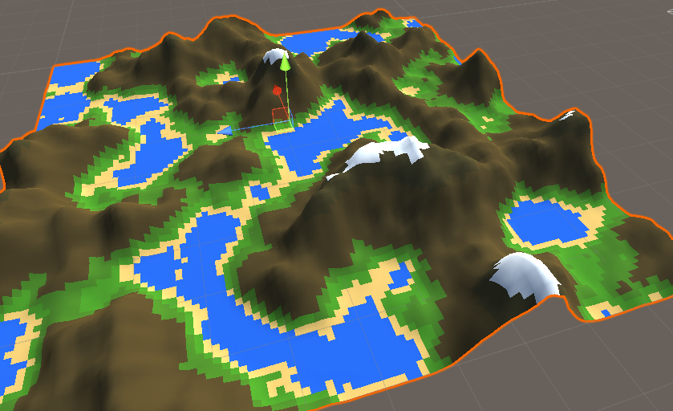

Figure 11 - Terrain Generation with low level of lacunarity | Terrain Generation with high level of lacunarity

### Sprint Review

The sprint was an overall success, in only 23 hours the author was able to have a terrain procedural generated. At this moment all the sprints are going ahead of time and no major problem was encountered so far. In this sprint the author not only learned how to effectively create a Mesh Class and how to manipulate the creation of a mesh by code but also how to use the animation curve to limit the values from the noise map.

### WBS

1. Research (50%) (12 hours)
2. Create a Mesh Class (40%) (9 hours)
3. Generate the Noise Map to add the height for each vertex (10%) (2 hours)

## Sprint 5 – Graphic interface to change the terrain generation on the go and Level of detail implementation 09/03/2019 – 18/03/2019

### Abstract

This sprint is going to be split in two different sections. The section one is where the author is going to focus on the development of user interface, the interface is going to be simple but effective. The goal is to have a user interface easy to use were the user can contemplate all the changes that the terrain goes through.

The second goal of this sprint is to implement a method to change the level of detail on the terrain, this is needed in case the author decides to implement an endless terrain generation.

### Research / Implementation

The first thing that the author did in the research for creating a user interface was going through the unity documentation (Unity Technologies 2019).

#### User Interface

##### Implementation

With previous knowledge in user interface development for unity and a good look at unity documentation a simple user interface was implemented [Figure 1].

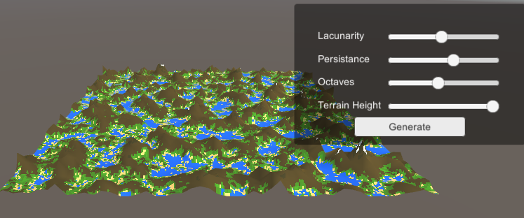

Figure - User Interface

##### Process

The process for implementation of the UI was straight forward, after having the design ready was time to work in the code.

The author wanted to update the lacunarity, persistence, octaves and terrain height variables only when the slider values changed, instead of updating them every frame. To implement this solution, the first step was to create an array of Sliders, this variable is public of type UnityEngine.UI.Slider and is implemented inside the script MeshGeneration [Figure 2].

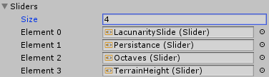

Figure - Sliders Array in Unity

After this the author created inside the start function a set of listeners for each slider that checks when the slider value changes [Figure 3].

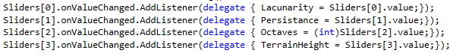

Figure - Listeners

#### Level of Detail (LOD)

When researching in how to implement the level of detail, the author found that unity already had this technique pre-build in the engine (Unity Technologies 2019).

Practically it works by checking the distance each object is from the camera. The farther an object is from the camera the smaller the number of triangles is needed to be rendered.

To use this in unity is necessary to go to a 3D program like Maya or Blender and when creating a mesh set the mesh name for something like meshName_LOD0 (Brackeys 2018). Each of this meshes have less triangles on them, being the LOD0 the one with the highest triangles count [Figure 4].

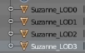

Figure - Name convention in Blender

After the mesh is created an imported into Unity, the engine automatically detects the mesh name and creates something named LOD Group in the game object (Arndt 2014) [Figure 5].

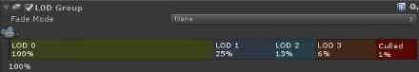

Figure - LOD Group in Unity

This pre-build functionality was good but far away from what the author was looking for, so with the idea of level of detail in mind, he started to implement this technique directly on the mesh generator class.

##### Implementation

The idea was simple, reduce the quantity of triangles to be created in the mesh by a certain amount. When trying to implement the method to reduce the level of detail of the mesh, few problems arise.

##### Problem and Solutions

The first problem took some time to understand how to solve it, every time the author tried to decrease the level of detail of the mesh, the render was totally wrong [Figure 6].

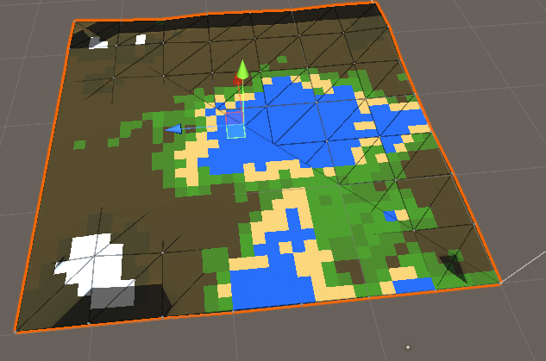

Figure - Mesh Rendering Problem

To resolve this issue, the author created a new method named Update Mesh Data, this method takes an int as a parameter and updates the mesh data by passing the vertices per line of the mesh. The value of the vertices per line is just the Size of the map divided by the level of detail [Figure 7].

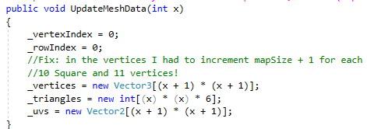

Figure – Update Mesh Data method

The second problem arise just after the first one was solved, now the level of detail of terrain got decreased, it was noticeable to the eye, even because the number of triangles were reduced in relation of the LOD (the higher the less triangles), but there was a problem, some of the triangles on the mesh were not been rendered properly [Figure 8].

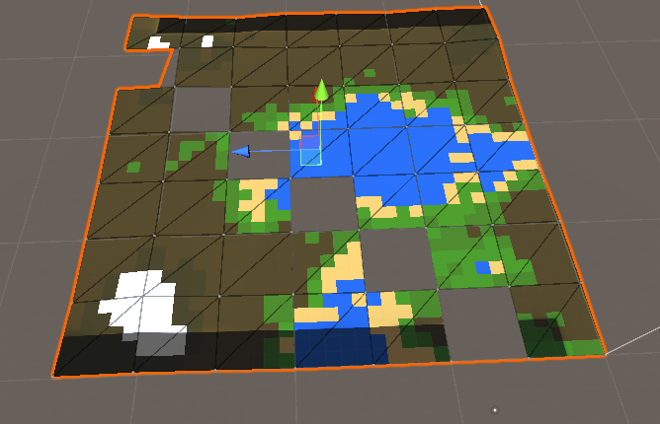

Figure - Terrain Rendering, invisible triangles

To solve this problem the first thing that came to the author mind was googling it and searching for: “how to implement level of detail of a mesh in code” but nothing helpful was found.

The next step was debugging the code and check step by step what was happening. The author then decided to use a sketchbook to draw some programming logic to think through in how the terrain generation was been processed [Figure 9].

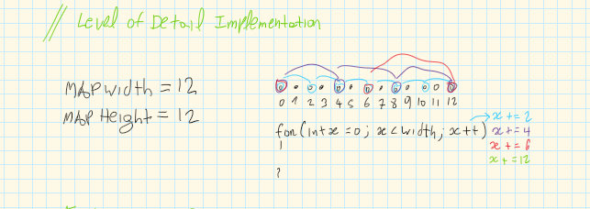

Figure - LOD

Sketching the problem not only helped to figure out the solution but also created a clear view in how to manipulate the triangles in the terrain. So, at this point the author discovered that the formula for the number of vertices needed were:

$V= \frac{MapSize}{x}+1$

The author then decided to create a terrain with a fixed size of ${255}^{2}$, to do this it was necessary to know what numbers are divisible by 255 with a result of the division been an integral value. The first thing that came to the author mind was searching for the factors of 255. The divisors of 255 were the following: 1,3,5,15,17,61,85,255 [Figure 10].

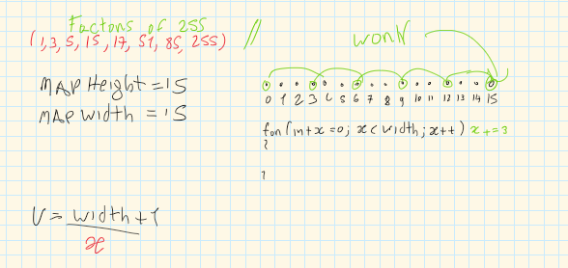

Figure - Factors of 255

Now with the vertex’s formula created and knowing all the factors of 255 with a fixed map size, implementing the final solution was easy. It is possible to see when the author tried to create a mesh with a map size of 15 [Figure 11] that for 15 quads there are 16 vertices $V= \frac{15}{1}+1;V=16$ and when the level of detail is 5, 4 vertices are created and only 3 quads $V= \frac{15}{5}+1;V=4$.

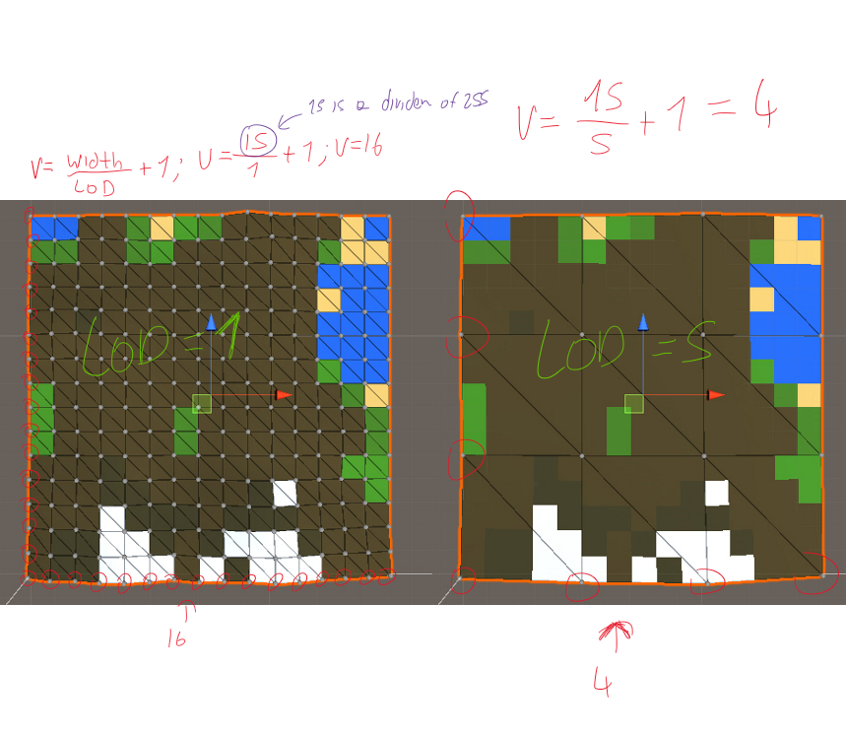

Figure - Level of Detail fully implemented

### Sprint Review

The sprint was a success, the author was able to create a simple user interface to be improved in future sprints and a method to reduce the level of detail of a mesh. This sprint gave the logic needed to the author for creating better mesh manipulation in future sprints.

### WBS

1. Research (30%) (24 hours)
2. Create a user interface (8%) (6 hours)
3. Implement the level of detail functionality (62%) (48 hours)

## Sprint 6 – Studying fractals and fractal implementation for future using in hydraulic erosion 22/03/2019 – 05/04/2019

### Abstract

This sprint is going to cover the process that the author went through when studying and creating the fractals. The reason why the author is studying fractals, lies on the fact that these geometrical figures are wildly found in nature. For example: For creating a river that go through the mountain is necessary a fractal design that creates different river nodes, where in the end these nodes create a river network, like the one in the image bellow [Figure 1] (Génevaux et al. 2013).

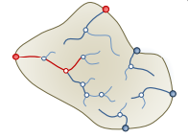

Figure - Génevaux et al. 2013. Fractal Network [digital image] [viewed 22 March 2019]. Available from:

<https://www.researchgate.net/profile/Eric_Guerin2/publication/248703095_Terrain_Generation_Using_Procedural_Models_Based_on_Hydrology/links/00b7d53c52bcd657e3000000.pdf>

### Research / Implementation

#### What is a Fractal?

##### Introduction

The term fractal derived from the mathematician Benoit Mandelbrot in 1975. Mandelbrot (1983) defined a fractal as

“a rough or fragmented geometric shape that can be split into parts, each of which is (at least approximately) a reduced-size copy of the whole”

Fractals are a collection of distinct objects with non-integral Hausdorff dimension (JOHN E. HUTCHINSON 1981).

This dimension was introduced by a mathematician named Felix Hausdorff in 1918 and is a measure of roughness or smoothness (Tilmann Gneiting, Hana Ševčíková and Donald B. Percival 2012).

Different from the Euclidean geometry [Figure 2], fractals simulate the geometry of nature [Figure 3]

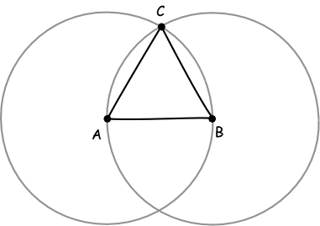

Figure - NORTON, J., 2006. Euclidean Geometry [digital image] [viewed 22 March 2019]. Available from: https://www.pitt.edu/~jdnorton/teaching/HPS_0410/chapters/non_Euclid_fifth_postulate/index.html

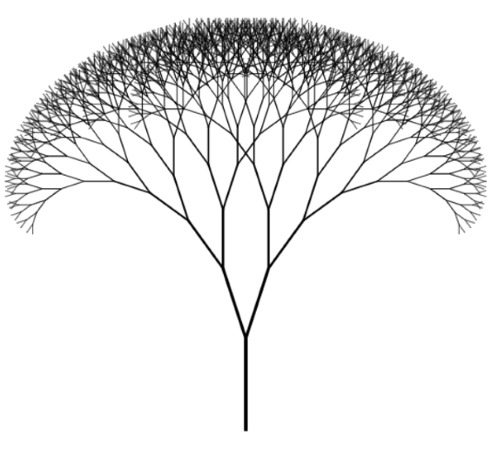

Figure - Seemann, M., 2017. Fractal Tree [digital image] [viewed 22 March 2019]. Available from: https://blog.ploeh.dk/2017/06/06/fractal-trees-with-purescript/

According to Falconer (1990) fractals should be only characterized by the following features:

##### Self-Similarity

Mandelbrot (1983) stated that each part of a fractal is a “reduced-size copy of the whole”. In the [Figure 4] it is possible to see the Sierpinski triangle, where not only every part of this fractal is repeated inside of itself but also the smallest section is an identic copy of the Sierpinski triangle, this is known as self-similarity.

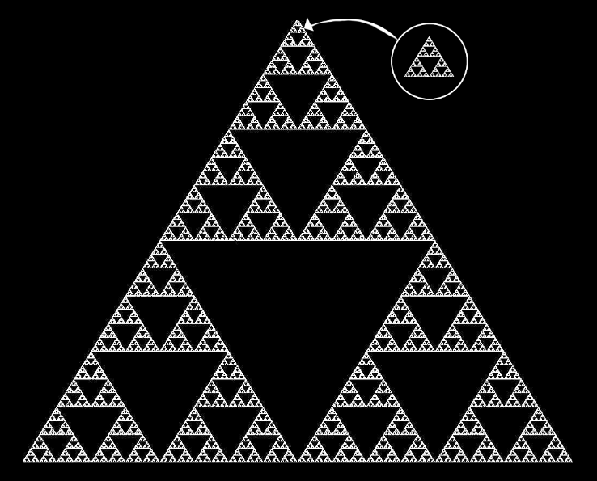

Figure - Sierpinski Triangle

In the example above it is possible to see a perfect self-similar fractal, however fractals do not have to be always perfectly self-similar.

It is possible to see in [Figure 5] the Mandelbrot set, this set produces similarly complex fractal shapes, even if they are similar, some of the shapes are distorted and degenerated, creating this random look.

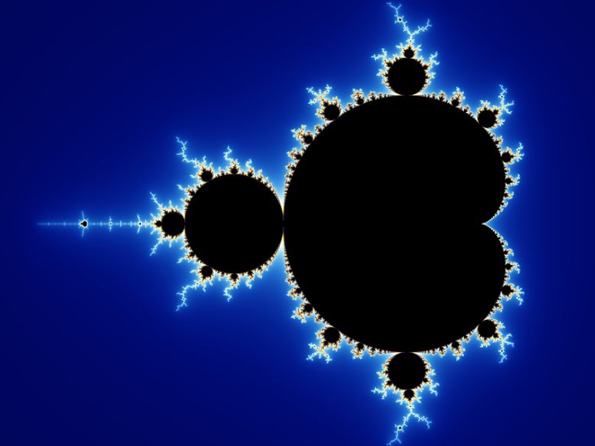

Figure - Beyer, W., 2013. Mandelbrot set [digital image] [viewed 22 March 2019]. Available from: <https://en.wikipedia.org/wiki/Mandelbrot_set#/media/File:Mandel_zoom_00_mandelbrot_set.jpg>

##### Fine structure at small scales

This feature is essential in a fractal, making the fractal built out of probabilities and randomness, this is known as a stochastic fractal. While self-similarity is important to define a fractal, it cannot be defined only by it. For example, a line is self-similar, but it is not a fractal; fractals are characterized by having a fine structure at small scales, practically they cannot be described with Euclidean geometry.

A good example of a stochastic fractal is the stock market graph. In [Figure 6] and [Figure 7] is an example of two stock graphs with different timelines from Apple, even if they look practically the same, without a label around the graphs is impossible to tell the time scale. They can be over one year, one month or one day, so by zooming into the stock market graph is possible to find fluctuations and randomness. In this case [Figure 6] is one year and [Figure 7] one month.

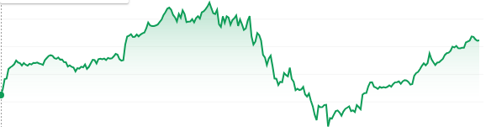

Figure - Apple Inc., 2019. Market Summary of 1 Year [digital image] [viewed 28 March 2019]. Available from:

https://www.google.com/search?safe=off&sa=X&rlz=1C1CHBF_enPT776PT776&tbm=fin&q=NASDAQ:+AAPL&stick=H4sIAAAAAAAAAONgecRoyi3w8sc9YSmdSWtOXmNU4-IKzsgvd80rySy



Figure -Apple Inc., 2019. Market Summary of 1 Month [digital image] [viewed 28 March 2019]. Available from:

https://www.google.com/search?safe=off&sa=X&rlz=1C1CHBF_enPT776PT776&tbm=fin&q=NASDAQ:+AAPL&stick=H4sIAAAAAAAAAONgecRoyi3w8sc9YSmdSWtOXmNU4-IKzsgvd80rySy

##### Recursive

One important feature of a fractal it that it needs to be recursive. Every fractal has a recursive definition, practically it keeps growing and getting small for each recursion until it reaches a point it cannot shrink anymore, and that it is the exit point.

#### Coding a Fractal

So, the author decided that for creating a fractal he needed to learn how to draw a line in unity. After a quick search, he found that for drawing basic lines, learning how to use the LineRender in unity was necessary (Unity School 2016).

##### Line Class

The author started creating a Line Class, this class have a method for Drawing a line, each time this method is called, it creates a game object and it stores it inside a list. The struggle here was not only drawing the line and being able to draw the next line saving the position from the line before but also apply a specific rotation if needed. To be able to do this the author created two vector 3, a quaternion and a Boolean variable [Figure 8].

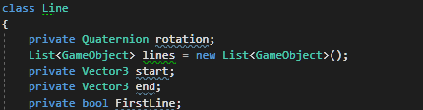

Figure - Line Class Variables

Afterwards he defined that the game object position is going to be equal to the start position and, in the end, when the line is created, the start position is going to be equals to the end position. When going through the list it was necessary to find a way to check if the line was not drawn yet, for this an if statement was implemented for checking if the game object had the line Renderer component, if not then draw the next line [Figure 9].

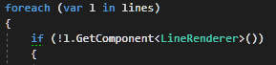

Figure - Check if the line is already drawn

When compiling the code, it is possible to see that the lines are created upon the length variable defined in the parameter of the branch method [Figure 10]. Then the next lines of code are responsible for setting the rotation and redrawing another line. This creates the result that can be seen in [Figure 11].

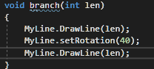

Figure - Fractals Step 1



Figure - Line Drawing

When the function is called recursively, a strange problem appears [Figure 12], it seems that the lines are not being translated in a proper way. For this it is necessary to find the exact position where the line before ends and pass it to the new line starting position.



Figure - Error when calling the function with recursion

The problem was found on the position for each line, the solution was setting the object position equals to the last object position and then multiplying by the last object rotation.

After many hours spent on the attempt to create a fractal, the author ended up with two interesting fractal patterns using only lines in unity [Figure 13] [Figure 14]. The end goal was to be able to create different patterns, for example a tree. This technique is going to allow the drawing of water paths when developing the hydraulic erosion algorithm.



Figure - Random Fractal by Flavio Fiori



Figure - Random Pattern 2

##### Fractal Tree

###### Introduction

A fractal tree is created by calling reclusively a method to creates a branch of the tree itself.

Frongillo, Lock and Brown (2007) defined the fractal tree as the following:

“A fractal tree can be loosely defined as a trunk and a number of branches that each look like the tree itself, thus creating a self-similar object. Often, these appear strikingly similar to real trees, and hence are used frequently as tree models.”

To be able to create the fractal tree the author decided to split the creation in three classes, the Fractal, Expander and Recursion script.

###### Fractals Script

The first idea when creating the fractal script was to think in how to approach the recursion of the object. The author decided to remove 1 value from the recursion variable when the script starts, so this means if the value of recursion is 1 the code is not going to run, the reason why, lies on the fact that there is already one object on the scene, so to see any visible results it is necessary at least two recursions.

For each value of recursion bigger than 1, a copy of this game object is instantiated and saved inside a variable. [Figure 15].

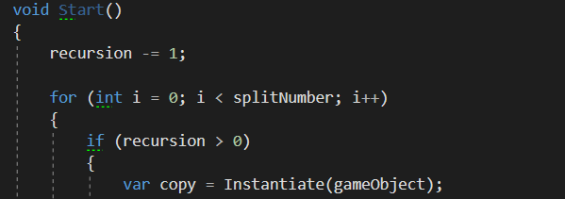

Figure - Recursion for the game object

The second step is to get the script named fractals from the game object and create a new class named Recursion [Figure 16].

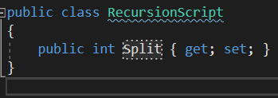

Figure - Recursion Script

This class is going to be only responsible to store the value from “i” in the for loop [Figure 15].

The last step is to use a function named Send Message; this function allows to call inside the same solution any method declared in a class that derives from MonoBehaviour (Unity 2018) [Figure 17].



Figure - Using Send Message Method()

###### Expander Script

This script contains the method that is called from the SendMessage() method that is used on the Fractal Script.

Let’s imagine that the variable defined in the Fractal Script named “splitNumber” as a value of 2, then the Split value can be 0 or 1. When the value is 1 then the rotation is positive, otherwise if is 0, the rotation is negative. The reason lies on the fact that multiplying any number by 0 by is always 0 then subtracting 1, the end result is -1 [Figure 18].

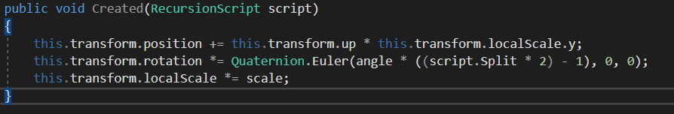

Figure - Created Method

###### Conclusion

The author ran the code in a cube, and a strange tree made of cubes was generated [Figure 19].

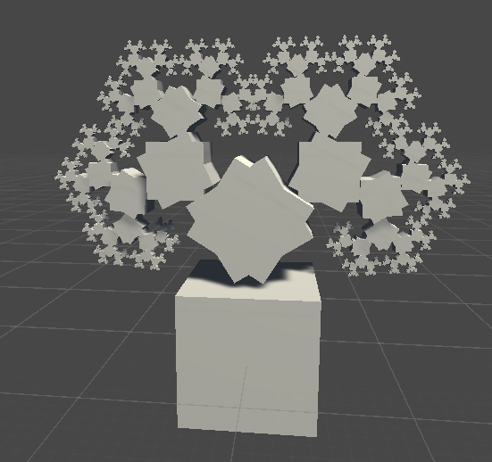

Figure - Fractal Cube

To improve the look, he decided to rescale the cube to look alike a branch from a tree [Figure 20], the cube scale was defined as follow: x = 0.1, y = 1 and z = 0.1

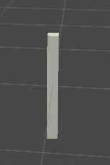

Figure - Tree Branch

When the code was compiled once again, the shape was similar to a tree, but the result was far from what the author expected [Figure 21].

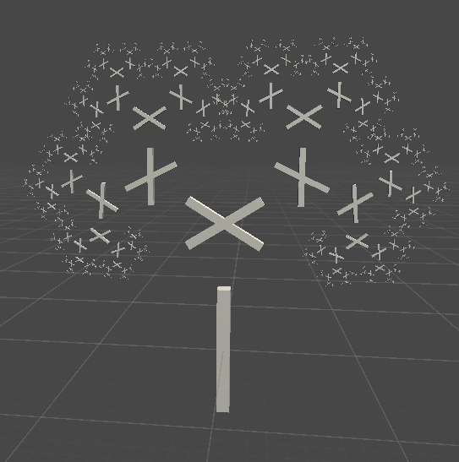

Figure - Tree Generation Failed

After a while looking for a solution, it was found that changing the position from the cube that was present inside the parent it improved the results in a drastic manner, the Cube Position value was set to Y = 1 [Figure 22].

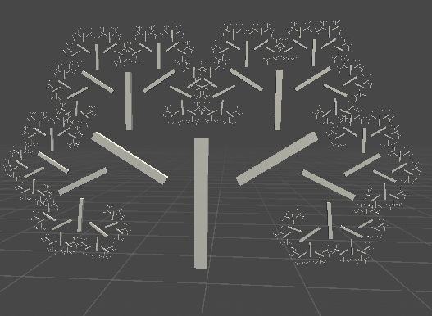

Figure - Cube Y Position changed to 1

The final result was found after playing for a while with the Y Position, the perfect Y value is 0.5f, resulting exactly in the fractal tree [Figure 23].

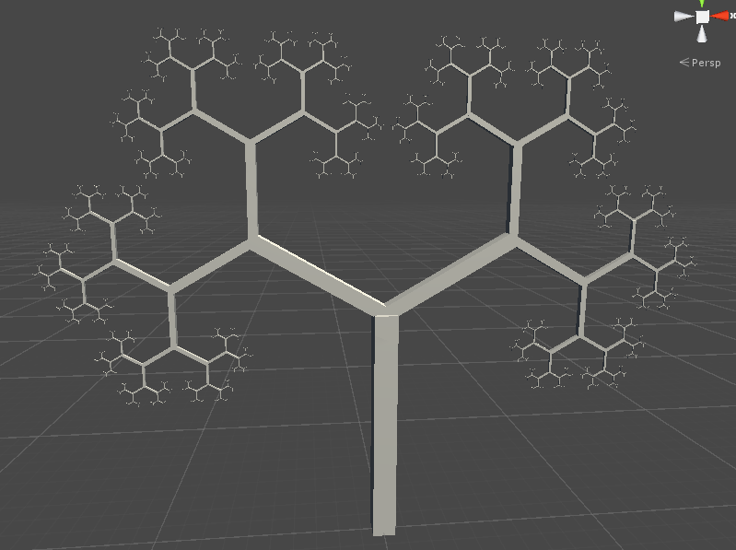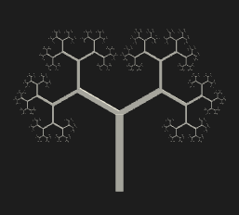

Figure - Fractal tree

### Sprint Review

This sprint was an overall success, not only it gave the necessary knowledge to the author for developing water paths inside the mountains using fractals but also to implement some trees in the map generation if time allows.

### WBS

1. Research (60%) (36 hours)
2. Fractal Generation (40%) (24 hours)

## Sprint 7 –hydraulic erosion 06/04/2019 – 01/05/2019

### Abstract

The goal of this sprint is to implement the hydraulic erosion algorithm to simulate real water erosion on the terrain mesh. Not only this is one of the largest sprints but also one of the most important ones. Optimisation techniques are discussed within this sprint.

The end goal of this sprint is the ability for the user control the quantity of erosion created by the water particles and a terrain mesh with visible erosion effects.

### Research

#### What is erosion?

##### Introduction

Erosion is a process that occurs in nature. This process is responsible for removing sediment from certain materials, like soil or rock, and carry this sediment to another location.

Erosion can be divided into different types: water erosion, glacial erosion, snow erosion, wind erosion, zoogenic erosion and anthropogenic erosion.

Due to the fact that the erosion algorithm for this project is going to be water erosion, all the other erosion types are not going to be covered in this document.

##### Water Erosion

###### Introduction

Water erosion happens when the particles of water come in contact with a saturated soil or in a greater rate at which water can infiltrate. It is composed by two process, the first is the erosion of the soil and the second is transporting the soil into the flow and start the deposition process.

Water erosion can be divided into four different types: sheet erosion, rill erosion, gully erosion and streambank erosion.

###### Sheet Erosion

Sheet erosion occurs in soils where the surface is mainly smooth and with a uniform slope. This type of erosion is responsible for removing uniform thin layers of soil on the entire field during a long period of time. So, it is possible to imagine that after a few years of removing thin layers, the terrain can be eroded by a significant amount (Fairbridge 1968).

Two basic erosion processes are involved in this type of erosion. First, the water collects the particles of soil and stores them as sediment into the water flow and second the particles are then transported away from the its original location to be deposited afterwards as sediment.

###### Rill erosion

Rill erosion occurs when the water from rain accumulates on a top of a terrain and then begins to flow, using the path of least resistance, creating paths or rills on the terrain itself [Figure 1].

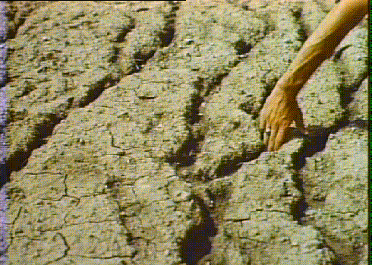

Figure - Milford. Rill Erosion [digital image] [viewed 08 April 2019]. Available from: https://milford.nserl.purdue.edu/weppdocs/overview/images/rillb.gif

The amount of sediment removed from the soil is proportional to the square velocity of the water flow. So, in other words, this means that if the velocity is 4 feet per second then the capacity of removing sediment from the soil is going to be sixteen times greater. To conclude is possible to see that the greater the water velocity the greater the sediment capacity from the water is going to be (Food and Agriculture Organization 1978).

###### Gully Erosion

This type of erosion occurs when the water flow erodes the soil in a way that creates large ditches [Figure 2]. Gully erosion is dependant of large quantities of water for supplying the necessary energy for removing and transporting the sediments.

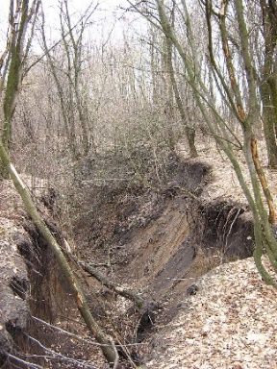

Figure - Киля, К., 2008. Gully in the Kharkov region in a small cut forest [digital image] [viewed 22 March 2019]. Available from:

https://en.wikipedia.org/wiki/Gully#/media/File:Gully_in_the_Kharkov_region.jpg

###### Streambank Erosion

Streambank erosion is a process that occurs in nature when the water flow can exert a stronger force than the soil around. Normally if the water flow passes through a vegetated bank the quantity of erosion is going to be lower, this lies on the fact that the vegetation creates a resistance force against the water flow reducing the erosion. However, if the bank around the water flow does not have vegetation to create a resistance force, the erosion can be brutal (Klausmeyer 2015; Reckendorf 2010).

The soil around the water flow is known as banks of the stream (Leopold, Wolman and Miller 1995).

In the [Figure 3] is possible to see an example of streambank erosion.

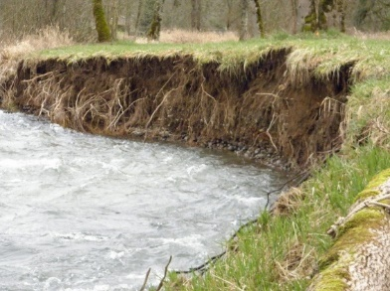

Figure - McQueeney, C., 2017. Eroding streambank causes property loss and degraded habitat for fish and wildlife [digital image] [viewed 10 April 2019]. Available from: https://i0.wp.com/conservationdistrict.org/wp-content/uploads/Bank_erosion_Milk_

###### Instant Terra

Instant Terra is a 3D application made in C++ for Procedural Terrain Generation. This application was used to get an idea in what should be expected from hydraulic erosion [Figure 4] [Figure 5] [Figure 6].

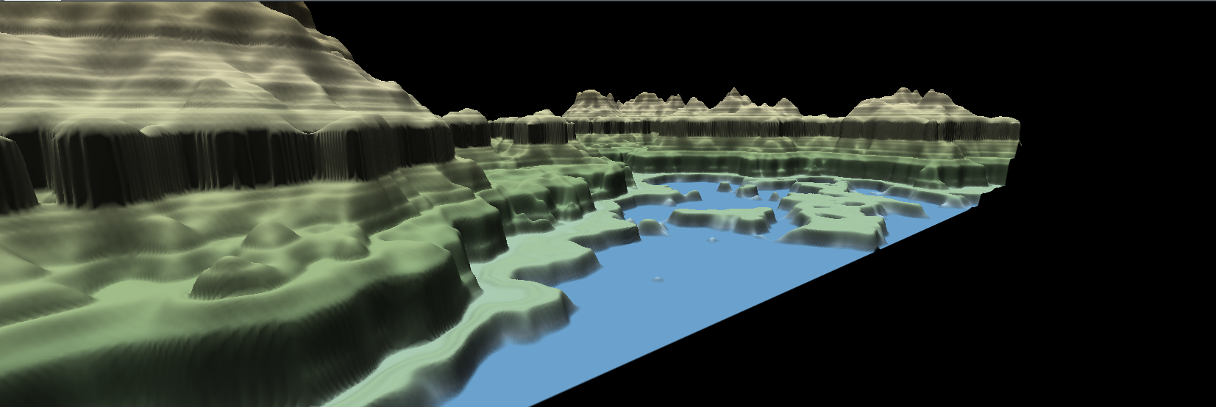

Figure - Instant Terra, terrain without hydraulic erosion

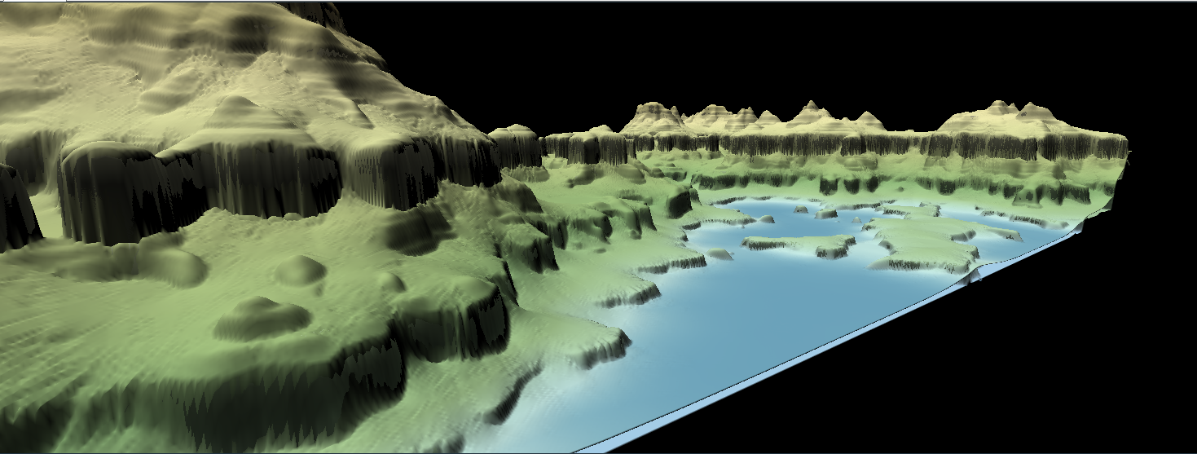

Figure - Instant Terra, terrain with hydraulic erosion

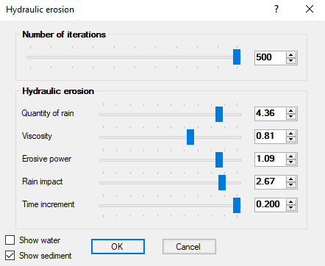

Figure - Instant Terra, hydraulic erosion settings

The algorithm that the author of this project created is inspired in the water erosion algorithm create by (Volynskov, 2011). It is based on the particle simulation in which every single water particle is placed into the map, where every particle as a certain radius with the capacity to erode the terrain around it and afterwards bringing the sediment to the path of least resistance.

### Implementation

#### Algorithm

##### Water Particles

Each particle uses the gradient function to get a direction. If the gradient is zero, a random direction is generated.

The drops are simulated in 2.5D which means the drop is always considered to be at ground level, and only saves its position in two dimensions.

* Particles do not interact
* Do not use the physical principles
* Particles move the same distance every simulation step, although they are not bound to the grid.
* The simulated time per step is not consistent.
* Not suitable to simulate fluids visually.

###### Understanding Water Erosion

Water erosion is composed by two different steps, the first step is erosion and the second is deposition.

In the first step the flow of water starts its erosive activity when going through the land in a steep gradient. When the gradient starts to get a value near zero or the water flow reached the limited amount of soil that can carry then the water starts the deposition process. Normally it is possible to see the most amount of erosion when the flow of water it is at highest speed and the amount of water have a low quantity of sediment.

This amount of soil depends on the following variables:

* + Surface Slope
  + Amount of water
  + Speed of the flow

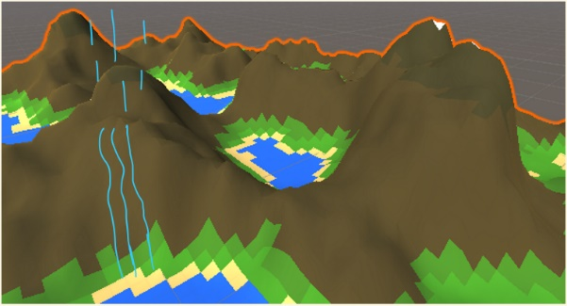

Figure - Water Flow

Erosion

* + If the quantity of soil is less than the maximum quantity of soil, then erosion happens.
  + This process removes soil from the terrain and adds it to the flow.

Deposition

* + If the water flow carries more than the maximum quantity then deposition happens, dropping extra carried soil as sediment.

#### Erosion Class

When sketching the erosion class, the author wanted to create a particle inside the erosion method [Figure 8]. Each particle is created inside two for loops one that checks for the number of iterations given by the user and the other for the lifetime of each particle. Each particle consists on the following:

* Vector2 Position
* Vector2 direction
* Float Water Velocity
* Float Water amount
* Float Sediment

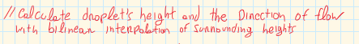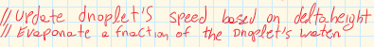

Figure - Erode function Sketch

##### Erosion Method

###### 1)Particle Creation

The first step was to create a particle of water at a random point in the map [Figure 9], to be able to do this the author used the Random class from C# (Microsoft .Net 2018).

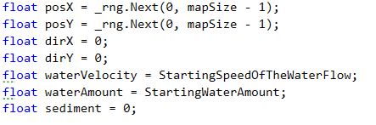

Figure - Particle Creation

###### 2)Converting the Particle Position and creating an Index for the particle

When the position of the particle is defined, a for loop for the lifetime of the particle is created. In the beginning of this for loop the integral position of the particle is saved inside the node variable [Figure 10].



Figure - Passing the variable position to an integral value named node position

Giving some random numbers like the ones defined in the image above, is possible to know exactly where the particle is located at [Figure 11].

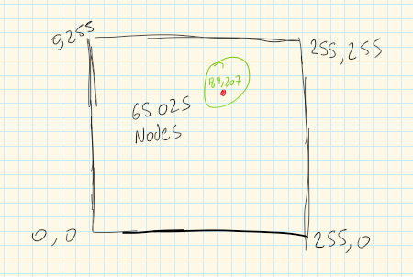

Figure - Particle Location

Now it is necessary to get the index of the particle, the reason lies on the fact that this index is going to be later used for finding the particle position on the map passed in the parameters of the Erode method. To be able to get the index the author used linear interpolation $y=mx+c$ [Figure 12].

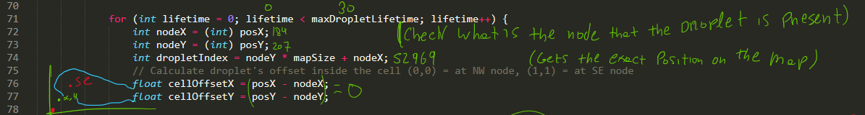

Figure - Example of a water particle creation

###### 3)Calculate and update the direction for the water particle using the gradient

For calculating the gradient for the particle of water the method named CalculateGradient() was used [Figure 13]. This method returns a value of type gradient; this value is defined inside the class as an internal struct to hold three values; height, x position and y position.

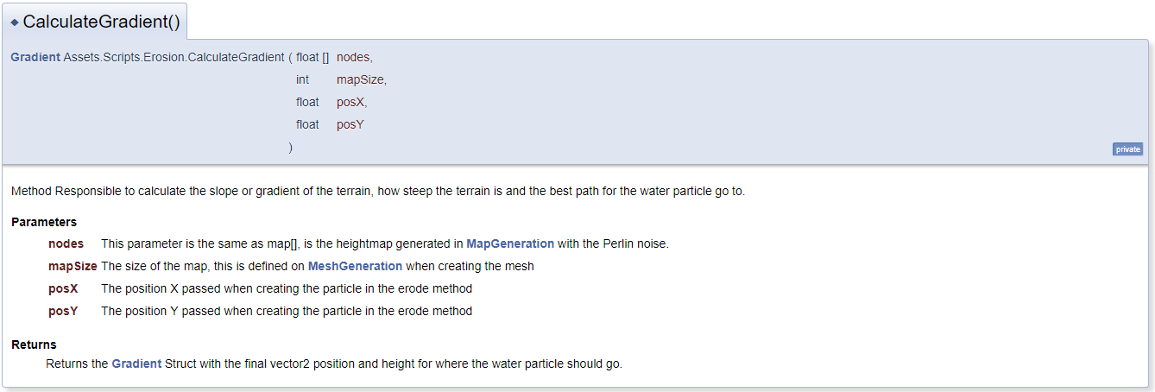

Figure - Calculate Gradient Method

Beyer (2015) sets the new particle direction using the following formula: $newDir=oldDir*Inertia-g*(1-inertia)$

In [Figure 14] it is possible to see how the author is updating the particle direction every loop. The reason why the author does not use inertia lies on the fact that he decided to implement it in a different way.

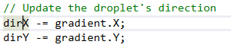

Figure - Update Particle Direction

The next step is to get the length between the x and y for normalizing the vector using the Pythagorean theorem [Figure 15].



Figure - Getting the length of the two positions ||V||

The last step is to get the normalized value from the dirX and dirY (Khan Academy 2019) [Figure 16]. When the value is normalized the author adds it to the position of the water particle.

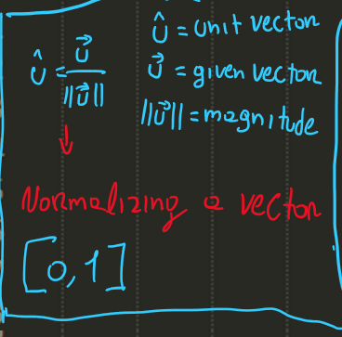

Figure - How to normalize a vector

###### 4) Calculate the new particle’s height

When the particle changes position, it is necessary to get the new current height where it is located. To do this the CalculateGradient method is called, storing the new height to a float variable [Figure 17].



Figure - New Height

The last step is to calculate the delta height between the old height and the new height. Delta in mathematics is simple the difference between a value and the other (Study.com 2019).

###### 5) Calculate the particle sediment capacity

For calculating the sediment capacity, the formula below was used (Volynskov 2011).

Formula

$$ED=\max\left(slope*v*w*ch, minslope\right)$$

* V = Water velocity
* W = Water amount
* Ch = constant value

###### 6) Erosion and deposition

Now that all the essentials are created the last part is to erode the map itself.

Erosion

When implementing the erosion, a certain amount to be eroded needs to be calculated. To do this it was necessary to set a minimum amount to erode [Figure 18].



Figure - Amount to erode

After this the author wanted to implement a type of inertia, he wanted to create erosions with different sizes to give some randomness in the map.

To do this the author created a float variable named weighedErodeAmount, and set it equals the amounToErode multiplied by a Random Range between 0.01f and Radius. With this, is possible to see a small but noticeable difference in the [Figure 19].

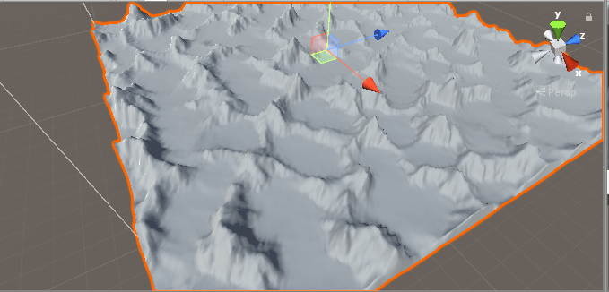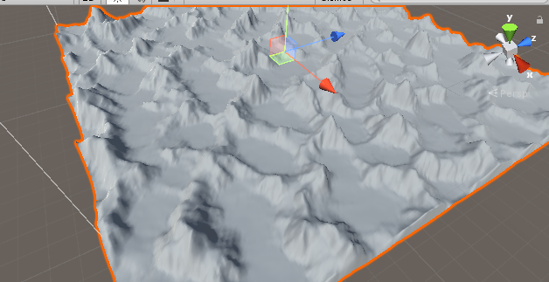

Figure - Before || After

Deposition

For this the first thing is to check if the sediment in the particle is bigger than the sediment capacity. If this turns to be true, then the amount to deposit equals to the sediment in the particle minus the sediment capacity.

##### Gradient Method

To implement the gradient method the first thing was studying how to do linear interpolation, bilinear interpolation and contour maps [Figure 18].

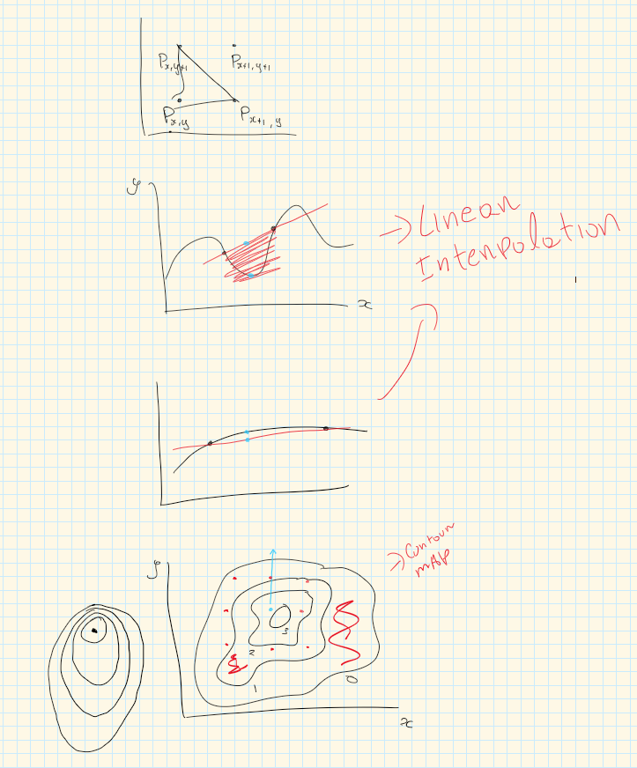

Figure - Droplet gradient calculation sketch

For calculating the gradient, the process was straightforward, check the images bellow.

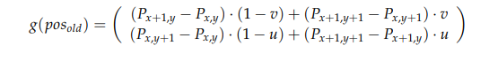

Figure - Beyer, H., 2015. Calculating a gradient using bilinear interpolation [digital image] [viewed 22 March 2019]. Available from:

<https://www.firespark.de/resources/downloads/implementation%20of%20a%20methode%20for%20hydraulic%20erosion.pdf>



Figure - Bilinear interpolation in code

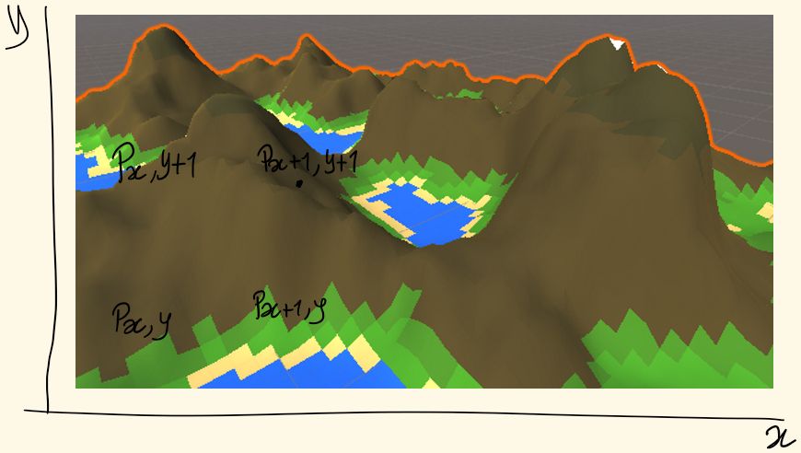

Figure - Calculating the four nodes of the particle.

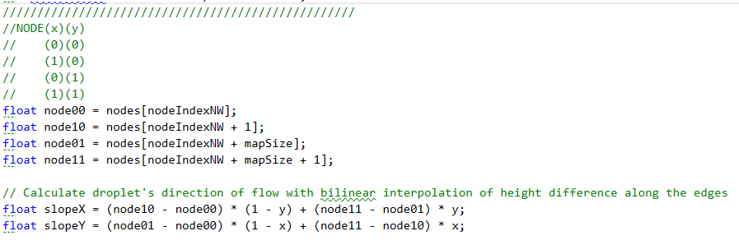

Figure - Gradient Implementation in Code

##### UML Erosion Class Design

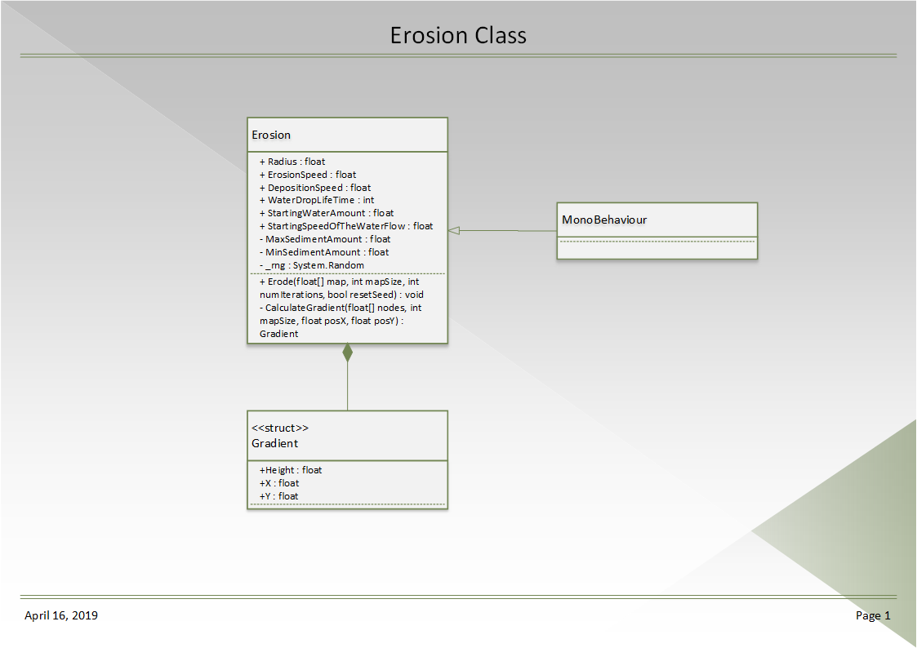

Figure - UML Erosion Class

### Sprint Review

This sprint not only gave the author a great knowledge in how to implement an erosion algorithm and modifying the mesh to apply the erosion but also improved his mathematics knowledge.

### WBS

1. Research (60%) (36 hours)
2. Fractal Generation (40%) (24 hours)

# References

ANDERSON, D.J., 2010. Kanban. Sequim, Wash: Blue Hole Press

CIRILLO, F., 2006. The Pomodoro Technique. [viewed 02/05/ 2018]. Available from: <http://baomee.info/pdf/technique/1.pdf>

CIRILLO, F., 2017. Do more and have fun with time management. [viewed 02/05/ 2018]. Available from: <https://francescocirillo.com/pages/pomodoro-technique/book/>

CUMMINGS, T., 2018. The Pomodoro Technique: Is It Right For You? [viewed 02/05/ 2018]. Available from: <https://www.lifehack.org/articles/productivity/the-pomodoro-technique-is-it-right-for-you.html>

FINLEY, K., 2014. WHY A SIMPLE TO-DO LIST TOOL IS WINNING OVER LEGIONS OF FANS [viewed 23/02/ 2019]. Available from: <https://www.wired.com/2014/08/why-a-simple-to-do-list-tool-is-winning-over-legions-of-fans/>

FOURNIER, A., D. FUSSELL and L. CARPENTER, 1982. Computer rendering of stochastic models. Communications of the ACM, Jun 1, 371-384

MARCUS HAMMARBERG and JOAKIM SUNDÉN, 2014. Kanban in Action. Manning Publications

OLSE, J., 2004. Realtime Procedural Terrain Generation. Department of Mathematics and Computer Science. University of Southern Denmark

OLSEN, J., 2004. Realtime Synthesis of Eroded Fractal Terrain for Use in Computer Games. Department of Mathematics and Computer Science

PETERSON, D., 2015. What is Kanban? [viewed 02/05/ 2018]. Available from: <http://kanbanblog.com/explained/>

PERLIN, K., 2002a. Improved Noise reference implementation [viewed 13/02/ 2019]. Available from: <https://mrl.nyu.edu/~perlin/noise/>

PERLIN, K., 2002b. Improving noise. ACM Transactions on Graphics (TOG), 21(3), 681-682

RIVEN, 2010. Calculate PerlinNoise faster with an optimization to grad(). In: August, Available from: <http://riven8192.blogspot.com/2010/08/calculate-perlinnoise-twice-as-fast.html>

ROHDE, S., 2013. Weathering and Erosion Basics [viewed 28/02/ 2019]. Available from: <https://www.youtube.com/watch?time_continue=0&v=CNUzTmPKxv8>

ROTHMAN, J., 2017. Why We All Use Timeboxes Available from: <https://www.agilealliance.org/why-we-all-use-timeboxes/>

SOFTWARE ADVICE, 2017. KanbanFlow Software [viewed 23/02/ 2019]. Available from: <https://www.softwareadvice.com/uk/project-management/kanbanflow-profile/>

ZUCKER, M., 2001. The Perlin noise math FAQ [viewed 10/02/ 2019]. Available from: <https://mzucker.github.io/html/perlin-noise-math-faq.html>

# Bibliography

ALEXANDRE PHILIPPE MANGRA, ADRIAN SABOU and DORIAN GORGAN, 2016. TSCH Algorithm - Terrain Synthesis from Crude Heightmaps. Romanian Journal of Human - Computer Interaction, 9(2), 119Top of Form

Bottom of Form

ANDERSON, D.J., 2010. Kanban. Sequim, Wash: Blue Hole Press

BECK, S., 2013. Minecraft in Unity 3D [Flashing Images] - One-Week Programming Challenge [viewed 10/01/ 2019]. Available from: <https://www.youtube.com/watch?v=qdwUkYrHosk&t=>

CIRILLO, F., 2006. The Pomodoro Technique. [viewed 02/05/ 2018]. Available from: <http://baomee.info/pdf/technique/1.pdf>

CIRILLO, F., 2017. Do more and have fun with time management. [viewed 02/05/ 2018]. Available from: <https://francescocirillo.com/pages/pomodoro-technique/book/>

CUMMINGS, T., 2018. The Pomodoro Technique: Is It Right For You? [viewed 02/05/ 2018]. Available from: <https://www.lifehack.org/articles/productivity/the-pomodoro-technique-is-it-right-for-you.html>

ESTEVEZ, C., 2019. What is HacknPlan? [viewed 23/02/ 2019]. Available from: <https://hacknplan.com/knowledge-base/what-is-hacknplan/>

FINLEY, K., 2014. WHY A SIMPLE TO-DO LIST TOOL IS WINNING OVER LEGIONS OF FANS [viewed 23/02/ 2019]. Available from: <https://www.wired.com/2014/08/why-a-simple-to-do-list-tool-is-winning-over-legions-of-fans/>

FLAFLA2, 2014. Understanding Perlin Noise [viewed 28/02/ 2019]. Available from: <http://flafla2.github.io/2014/08/09/perlinnoise.html>

FOURNIER, A., D. FUSSELL and L. CARPENTER, 1982. Computer rendering of stochastic models. Communications of the ACM, Jun 1, 371-384

GAMEDESIGNING, 2018. We Review The Hacknplan App [viewed 23/02/ 2019]. Available from: <https://www.gamedesigning.org/gaming/hacknplan/>

GÉNEVAUX, J. et al., 2013. Terrain generation using procedural models based on hydrology. ACM Transactions on Graphics (TOG), 32(4), 1-13

JAVIDX9, 2017. Programming Perlin-like Noise (C++) [viewed 01/03/ 2019]. Available from: <https://www.youtube.com/watch?v=6-0UaeJBumA>

NESO ACADEMY, 2018. Bitwise Operators in C (Part 2) [viewed 01/03/ 2019]. Available from: <https://www.youtube.com/watch?v=8aFik6lPPaA>

OLSE, J., 2004. Realtime Procedural Terrain Generation. Department of Mathematics And Computer Science, University of Southern Denmark,

OLSEN, J., 2004. Realtime Synthesis of Eroded Fractal Terrain for Use in Computer Games. Department of Mathematics And Computer Science,

PERLIN, K., Noise and Turbulence [viewed 28/02/ 2019]. Available from: <https://mrl.nyu.edu/~perlin/doc/oscar.html#noise>

PERLIN, K., 1985. An Image Synthesizer

PERLIN, K., 2001. Noise Hardware [viewed 27/02/2019]. Available from: <https://www.csee.umbc.edu/~olano/s2002c36/ch02.pdf>

PERLIN, K., 2002a. Improved Noise reference implementation [viewed 13/02/ 2019]. Available from: <https://mrl.nyu.edu/~perlin/noise/>

PERLIN, K., 2002b. Improving noise. ACM Transactions on Graphics (TOG), 21(3), 681-682

RIVEN, 2010. Calculate PerlinNoise faster with an optimization to grad(). In: August, Available from: <http://riven8192.blogspot.com/2010/08/calculate-perlinnoise-twice-as-fast.html>

ROHDE, S., 2013. Weathering and Erosion Basics [viewed 28/02/ 2019]. Available from: <https://www.youtube.com/watch?time_continue=0&v=CNUzTmPKxv8>

ROTHMAN, J., 2017. Why We All Use Timeboxes Available from: <https://www.agilealliance.org/why-we-all-use-timeboxes/>

SMELIK, R.M. et al., 2009. A Survey of Procedural Methods for Terrain Modelling.

SOFTWARE ADVICE, 2017. KanbanFlow Software [viewed 23/02/ 2019]. Available from: <https://www.softwareadvice.com/uk/project-management/kanbanflow-profile/>

THE CODING TRAIN, 2015. I.5: Perlin Noise - The Nature of Code [viewed 28/02/ 2019]. Available from: <https://www.youtube.com/watch?v=8ZEMLCnn8v0>

THE CODING TRAIN, 2016. 13.1: Introduction - Perlin Noise and p5.js Tutorial [viewed 28/02/ 2019]. Available from: <https://www.youtube.com/watch?v=Qf4dIN99e2w>

ZUCKER, M., 2001. The Perlin noise math FAQ [viewed 10/02/ 2019]. Available from: <https://mzucker.github.io/html/perlin-noise-math-faq.html>

# Appendix

## Appendix A) Reading List

ALEXANDRE PHILIPPE MANGRA, ADRIAN SABOU and DORIAN GORGAN, 2016. TSCH Algorithm - Terrain Synthesis from Crude Heightmaps. Romanian Journal of Human - Computer Interaction, 9(2), 119

Top of Form

Bottom of Form

FOURNIER, A., D. FUSSELL and L. CARPENTER, 1982. Computer rendering of stochastic models. Communications of the ACM, Jun 1, 371-384

GÉNEVAUX, J. et al., 2013. Terrain generation using procedural models based on hydrology. ACM Transactions on Graphics (TOG), 32(4), 1-13

OLSE, J., 2004. Realtime Procedural Terrain Generation. Department of Mathematics and Computer Science, University of Southern Denmark,

OLSEN, J., 2004. Realtime Synthesis of Eroded Fractal Terrain for Use in Computer Games. Department of Mathematics and Computer Science,

PERLIN, K., 1985. An Image Synthesizer

PERLIN, K., 2001. Noise Hardware [viewed 27/02/2019]. Available from: <https://www.csee.umbc.edu/~olano/s2002c36/ch02.pdf>

PERLIN, K., 2002. Improving noise. ACM Transactions on Graphics (TOG), 21(3), 681-682

SMELIK, R.M. et al., 2009. A Survey of Procedural Methods for Terrain Modelling.

## Appendix B) Literature review

### B.1) Terrain Synthesis Techniques Research

**THE CODING TRAIN, 2015. *I.5: Perlin Noise - The Nature of Code*[viewed 28/02/ 2019]. Available from:**[**https://www.youtube.com/watch?v=8ZEMLCnn8v0**](https://www.youtube.com/watch?v=8ZEMLCnn8v0)

**THE CODING TRAIN, 2016. *13.1: Introduction - Perlin Noise and p5.jsTutorial*[viewed 28/02/ 2019]. Available from:**[**https://www.youtube.com/watch?v=Qf4dIN99e2w**](https://www.youtube.com/watch?v=Qf4dIN99e2w)

These two videos introduced to me the Perlin Noise algorithm and how it works. They discuss that Perlin Noise is a pseudo-random noise, meaning that the values are not random at all, but the increment in a slow way, between the value 0 and 1.

**BECK, S., 2013. *Minecraft in Unity 3D [Flashing Images] - One-Week Programming Challenge*[viewed 28/02/ 2019]. Available from:**[**https://www.youtube.com/watch?v=qdwUkYrHosk&t=**](https://www.youtube.com/watch?v=qdwUkYrHosk&t=)

This link shows a finish product in unity, where the user develops a voxel world like Minecraft, using procedural terrain generation.

### B.2) Perlin Noise Research

**PERLIN, K., 2002. Improving noise. *ACM Transactions on Graphics (TOG),*21(3), 681-682**

This was the first Perlin Noise academic journal that I came across, practically this journal refers that the original algorithm of noise had two deficiencies.

Un-optimal gradient computation, in other words the gradient function was replaced by 12 defined vectors. The other deficiency was found on the fade function $3^{t2}-{2t}^{3}$ that was after replaced by $6^{t}-{15}^{t4}+{10}^{t3}$.

**FLAFLA2, 2014. *Understanding Perlin Noise*[viewed 28/02/ 2019]. Available from:**[**http://flafla2.github.io/2014/08/09/perlinnoise.html**](http://flafla2.github.io/2014/08/09/perlinnoise.html)

“Understanding Perlin Noise”, was in this web page that I learned all about the algorithm and how to recreate a working version of the Perlin Noise. This is just a copy of the original Perlin Noise but updated to the improved version of the algorithm.

**ZUCKER, M., 2001. *The Perlin noise math FAQ*[viewed 10/02/ 2019]. Available from:**[**https://mzucker.github.io/html/perlin-noise-math-faq.html**](https://mzucker.github.io/html/perlin-noise-math-faq.html)

This source is a combination from the Ken Perlin’s Making Noise web site, and the Higo Elia’s page, but unfortunately this web pages were taken down.

**PERLIN, K., *Noise and Turbulence*[viewed 28/02/ 2019]. Available from:**[**https://mrl.nyu.edu/~perlin/doc/oscar.html#noise**](https://mrl.nyu.edu/~perlin/doc/oscar.html#noise)

In this link Ken Perlin shows how to implement Perlin Noise function and how to do it using different dimensions functions.

**PERLIN, K., 1985. An Image Synthesizer**

Perlin describes five ideas for visual texture synthesis in this journal. The author introduces the concept of Pixel Stream Editor. Explaining how to develop efficient naturalistic looking textures. The author talks about how he used this system to create a believable representation of fire, water, clouds, waves, marble and oil films.

**RIVEN, 2010. Calculate Perlin Noise faster with an optimization to grad(). In: August, Available from:**[**http://riven8192.blogspot.com/2010/08/calculate-perlinnoise-twice-as-fast.html**](http://riven8192.blogspot.com/2010/08/calculate-perlinnoise-twice-as-fast.html)

The author discovered an efficient way to simplify the Perlin Noise algorithm changing the gradient function and making it twice as fast, returning the gradient directions in a simplified way instead of doing the complicated bit manipulation that Ken Perlin does on the original algorithm.

**NESO ACADEMY, 2018. *Bitwise Operators in C (Part 2)*[viewed 01/03/ 2019]. Available from:**[**https://www.youtube.com/watch?v=8aFik6lPPaA**](https://www.youtube.com/watch?v=8aFik6lPPaA)

This author thought me how the bitwise operators worked. This helped me understand how the bit manipulation of the gradient function of Ken Perlin worked.

**JAVIDX9, 2017. *Programming Perlin-like Noise (C++)*[viewed 01/03/ 2019]. Available from:**[**https://www.youtube.com/watch?v=6-0UaeJBumA**](https://www.youtube.com/watch?v=6-0UaeJBumA)

This author gives an overview and explains more in detail how to implement the algorithm in a different language like C++.

### B.3) Diamond-Square Research

**OLSE, J., 2004. Realtime Procedural Terrain Generation. Department of Mathematics and Computer Science, University of Southern Denmark**

In this journal the author implements the Diamond-Square algorithm, explaining how it works.

**OLSEN, J., 2004. Realtime Synthesis of Eroded Fractal Terrain for Use in Computer Games. *Department of Mathematics and Computer Science***

In this journal is where the idea of the diamond-square algorithm was introduced.

“First, we compute the boundary of the patch, using the one-dimensional version of the algorithm to the level desired. We then fill the square for each level, computing the centres, then the sides, using at each step the four neighbours (diagonally for the centres, horizontally and vertically for the sides). At each step the new point is computed as a Gaussian pseudo-random variable, whose expected value is the mean of the four neighbours at this level, and whose standard deviation is $c^{-lh}$, with $l$ the level, H the self-similarity parameter, and c a constant to be adjusted to fit the application” (Olse 2004)

## Appendix C) Images

### C.1) Prototype using the 2D Perlin noise function that I created

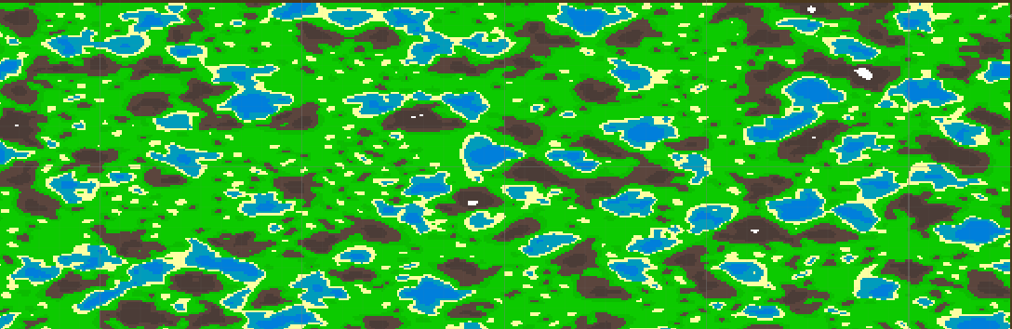

### C.2) Prototype using the Unity Perlin Noise Function

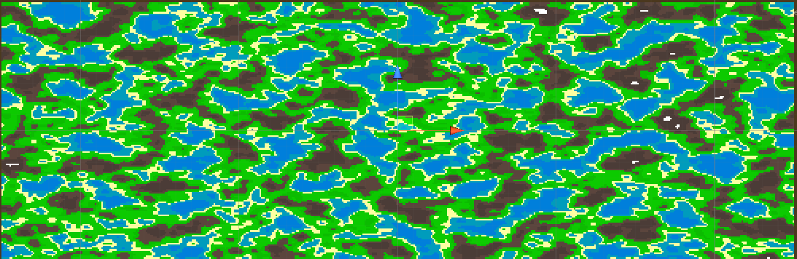

### C.3) Perlin Noise from my function

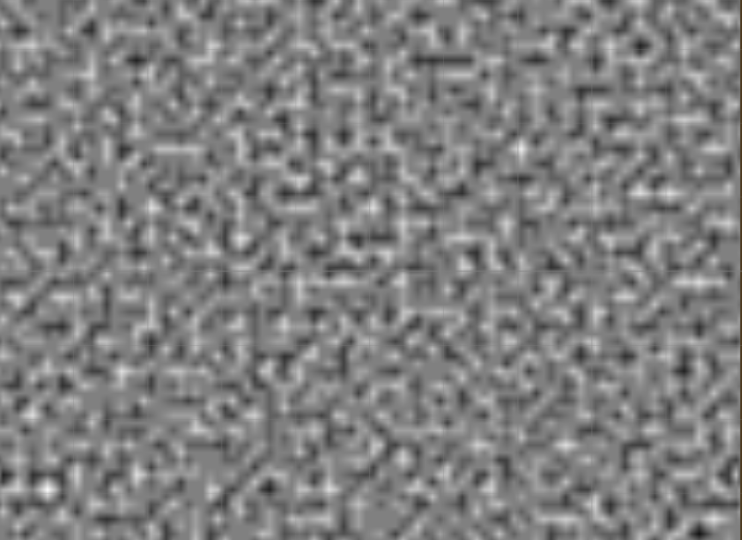

### C.4) Perlin Noise from unity

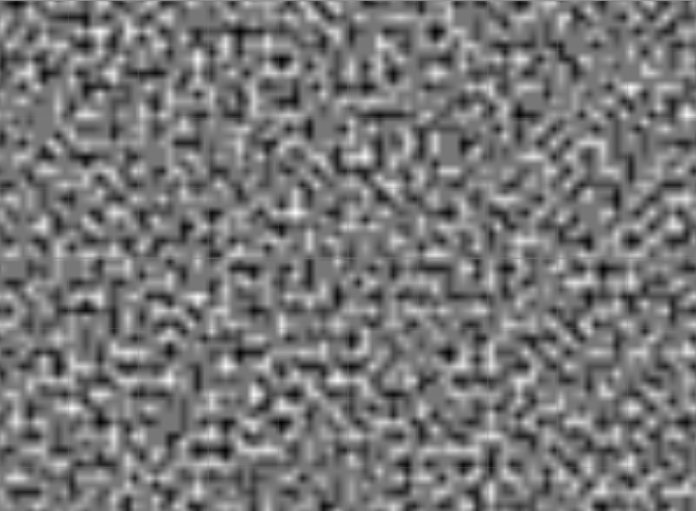

### C.5) Ken Perlin’s original gradient function

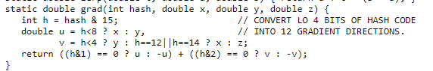

### C.6) Riven Calculate Perlin Noise twice as fast

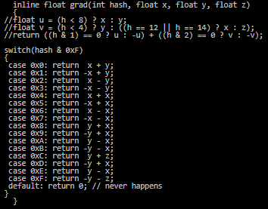

### C.7) Noise Displaced super quadric with old interpolants

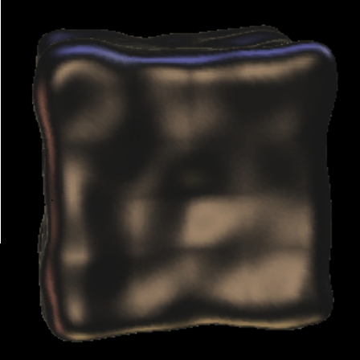

### C.8) Noise Displaced super quadric with new interpolants

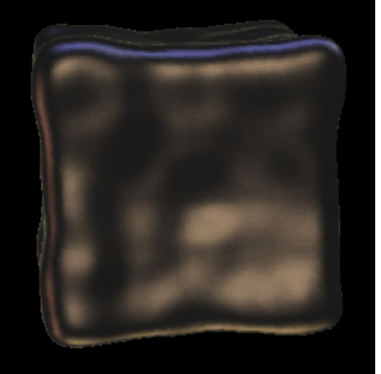

### C.9) Risk and Analysis



### C.10) Gantt Chart

